MORWELL TUNNELS –DESIGN OF A BURIED ARCH CULVERT UNDER VERY HIGH FILL

Doug Jenkins, Interactive Design Services Pty Ltd, Chris Lawson, Reinforced Earth Pty. Ltd.

The Morwell River Diversion project in the Latrobe Valley requires the construction of four conveyor tunnels to carry the main coal conveyors for the Morwell power station under more than 40 metres of fill. They are believed to be the deepest and longest conveyor tunnels constructed under fill in Australia. Reinforced Earth successfully tendered for the design and supply of the tunnels with a precast concrete arch design based on their TechSpan system. The contract required the design of a complete system, including raft foundations and waterproofing. In addition to very high fill loads the design was required to allow for very high settlements and the possible presence of acidic soils.

This paper describes the arch design process, which included both two and three dimensional finite-element analysis for the arch cross section design, and to check the effect of differential longitudinal loading and foundation conditions. The effect of many alternative ground improvement options was considered, in order to optimise the foundation design. The final design was developed after the award of the contract and used three different options, depending on the ground and weather conditions at the time of construction. The following information is presented in the paper:

- Comparison of bending moments and forces in the adopted arch profile with alternative profiles.
- Comparison of foundation bending moments and forces for different raft cross-sections and foundation treatments.
- Comparison of alternative analysis methods for the raft foundations
- Comparison of settlement analysis results with analyses carried out by the project primary designers (SMEC Australia).

INTRODUCTION

The Morwell River in Victoria’s Latrobe Valley is being diverted to allow access to brown coal deposits to fuel the Morwell power station. Joint venture partners, Roche, Thiess and Linfox (RTL), won the tender for this project in October 2001, with an alternative design that significantly reduced the length of the diversion, but which carried the river over four coal conveyors on an embankment over 45 metres high. The main design requirements for the culverts required to carry the conveyors under the embankment were as follows:

- The maximum fill height is over 45 metres, over deep brown coal deposits, resulting in very large differential settlement over the length of the culvert.
- The maximum culvert length is 365 metres, with a total length over the four culverts of 1100 metres.
- Culvert erection was required to be possible with minimum disruption to the operation of the conveyors.
- The design and supply package included the design and supply of the pre-cast concrete arch and waterproofing system, and design of the in-situ concrete foundations.
- The design life is 50 years, with the possibility of zones of acid generating material in the backfill.

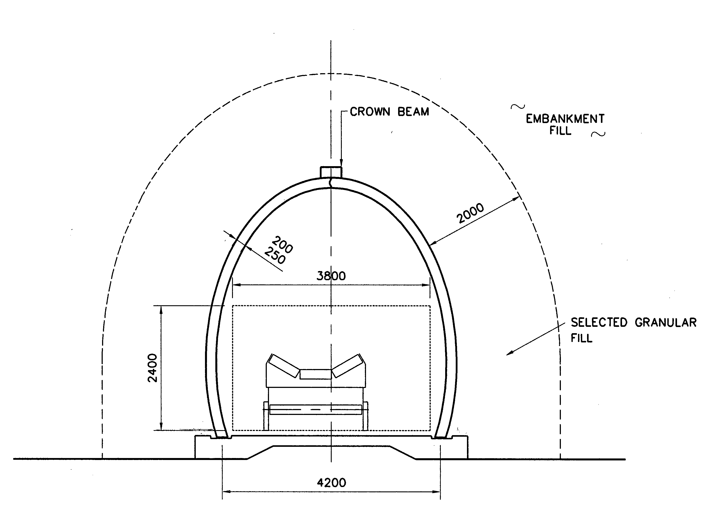
Fig. 1 Cross section of conveyor tunnel

CONVEYOR TUNNELS

The conveyor tunnel cross section is shown in Figure 1, and a photograph during erection in Figure 2. The arch design was based on the Reinforced Earth Pty Ltd TechSpan system, using a project specific arch profile designed to minimise the bending moments in the arch under the maximum fill heights.

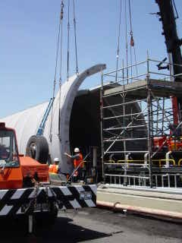
The system was modified to avoid the use of external galvanised steel components, due to the possible presence of acid generating backfill. The foundation slabs were designed in combination with improvement of the fill material to minimise the depth of the concrete. Different foundation designs were adopted during the course of the project, depending on the foundation and weather conditions.

Fig. 2 Erection of precast arch units
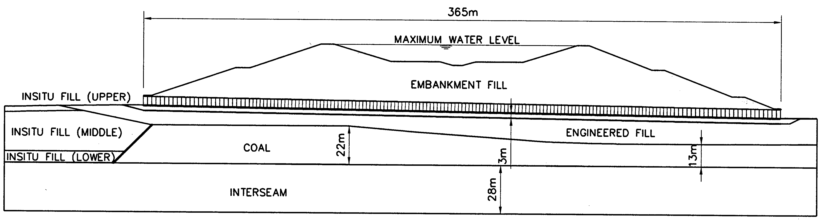

Fig. 3 Geotechnical long section

FOUNDATION CONDITIONS

Figure 3 is a long section showing typical foundation conditions under the conveyors, consisting of over 200 metres depth of alternating brown coal and interseam layers, overlain by fill of variable compaction. At the West end of the project the toe of the embankment is supported by about 30 metres of poorly compacted fill, which transitions rapidly to a brown coal layer. Upper and lower bound stiffness parameters were considered in the design, based on geotechnical testing and the performance of trial embankments.
The soil stiffness and strength parameters used in the analyses are summarised in Table 1:

Table 1: Soil Strength and Stiffness Parameters

Material | Internal Friction Angle | Cohesion | Density | Youngs Modulus  (kPa) |  | Poissons  Ratio
 | deg | kPa | Tonne/m3 | Min | Max
Embankment Fill | 28 | 5 | 2.0 | 20 | 60 | 0.3
Select fill | 36 | 0 | 2.0 | * | * | *
Engineered fill | 28 | 5 | 2.0 | 20 | 60 | 0.3
Dense fill | 36 | 0 | 2.1 | 50 | 100 | 0.3
Cement treated base | 0 | 500 | 2.2 | 1000 | 1000 | 0.3
In-situ fill - Upper | 28 | 5 | 1.9 | 10 | 30 | 0.3
In-situ fill – Middle | 28 | 0 | 1.8 | 4 | 10 | 0.1
In-situ fill - Lower | 28 | 5 | 1.9 | 10 | 40 | 0.3
Coal | 29 | 150 | 1.1 | 15 | 45 | 0.2
Interseam | 23 | 16 | 1.9 | 30 | 90 | 0.2

TRANSVERSE ANALYSIS

The transverse analysis of the arch and raft slab was carried out using the Reinforced Earth in-house finite element analysis software package “Aztech”. A typical finite element mesh is shown in Figure 4. The analysis models the construction of the embankment in stages, taking account of possible unbalanced loading and compaction loading. The model included the concrete raft foundation slab, and the underlying layers of fill and coal, allowing the interaction between the foundation slab and soil to be included in the analysis.

The arch cross section was designed to minimise bending moments under the maximum fill height. For the purposes of illustration of the effectiveness of the design section the forces in the actual arch profile have been compared with semi-circular and semi-elliptical profiles (Figure 5). Maximum bending moments are shown in Figure 6, and maximum shear forces in Figure 7. It can be seen that the adoption of a semi-circular profile increased bending moments by about 80% and shear forces by about 300%. Use of a semi-elliptical profile increased bending moments by about 320% and shear forces by about 370%. Use of the alternative profiles would have required the use of a thicker section, which would have resulted in additional increases in the arch actions. The optimised arch section also minimised the span of the raft foundation, resulting in a significant saving in the foundation cost.

The raft foundation slab was modelled in the arch finite element analysis, and the results of this analysis were used in the raft design. In addition the analysis was checked with a second finite element analysis of the complete arch and slab system, using Strand7, and also with a simpler model using elastic support elements. The models used for the alternative analyses are shown in Figures 8 and 9. The simplified model used plate elements to model the stiffer fill immediately under the raft, with elastic supports to the plates to model the foundation layers. The elastic stiffness of these supports was determined so that the total settlement of the raft slab was equal to that found in the finite element analyses.

In order to reduce bending moments in the slab the slab was reduced in depth over the central section, and fill material of higher stiffness was used under the slab. The combined slab and fill in effect acted as a deep beam, with the slab acting as a tension member. Different details were used in the final design (Figure 10), due to availability of suitable fill materials, weather conditions, and time constraints. Typical bending moment and shear and axial force diagrams for two foundation designs for the maximum fill height are shown in Figures 12 and 13. Figure 14 compares the bending moments from the adopted design with a flat slab design with unimproved foundations (see Figure 11). Increased bending moments and shear forces required the flat slab depth to be increased to 1200 mm. The increased stiffness of the slab reduces the effect of soil-structure interaction, resulting in a very high bending moment of 1500 kNm at the centre of the slab.

Fig. 4 Typical finite element mesh detail

The results of the three different methods of analysis are shown in Figures 15 to 17. It can be seen that there is good agreement between the three analyses for bending moments and shear forces, but the simplified analysis results for axial force are significantly different. This would be expected, since the stiffness of the supports in the simplified analysis was chosen to give the same vertical settlement as the full
analyses, but the simplified model
Fig.5 Alternative arch profiles does not model the horizontal
restraint on the foundation soils, or
the effect of the overburden pressure
outside the plan extent of the raft.

Fig. 6 Bending Moments for alternative arch profiles

Fig. 7 Shear forces for alternative arch profiles

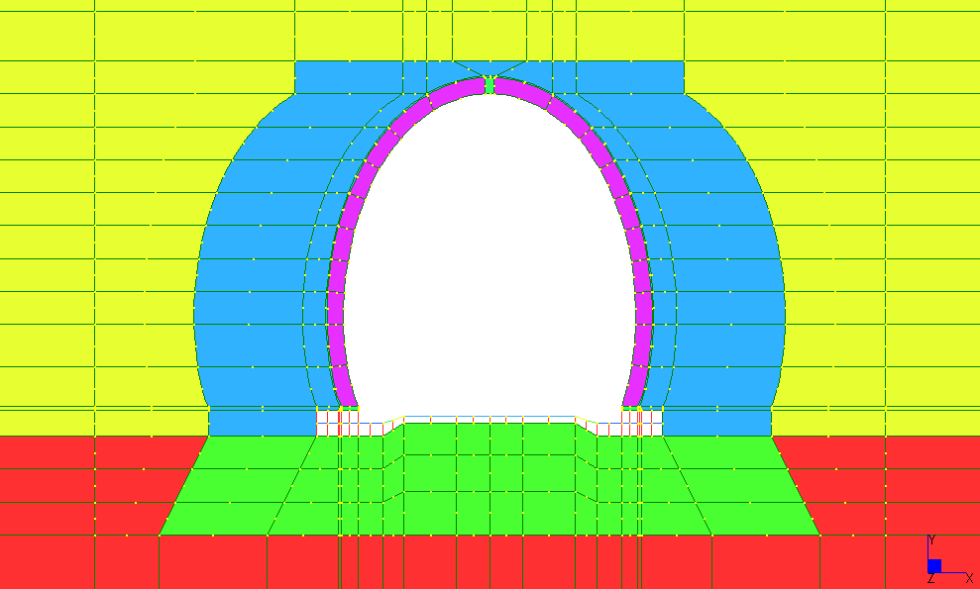

Fig.8 Strand7 FEA Model
Fig.9 Simplified Footing Model
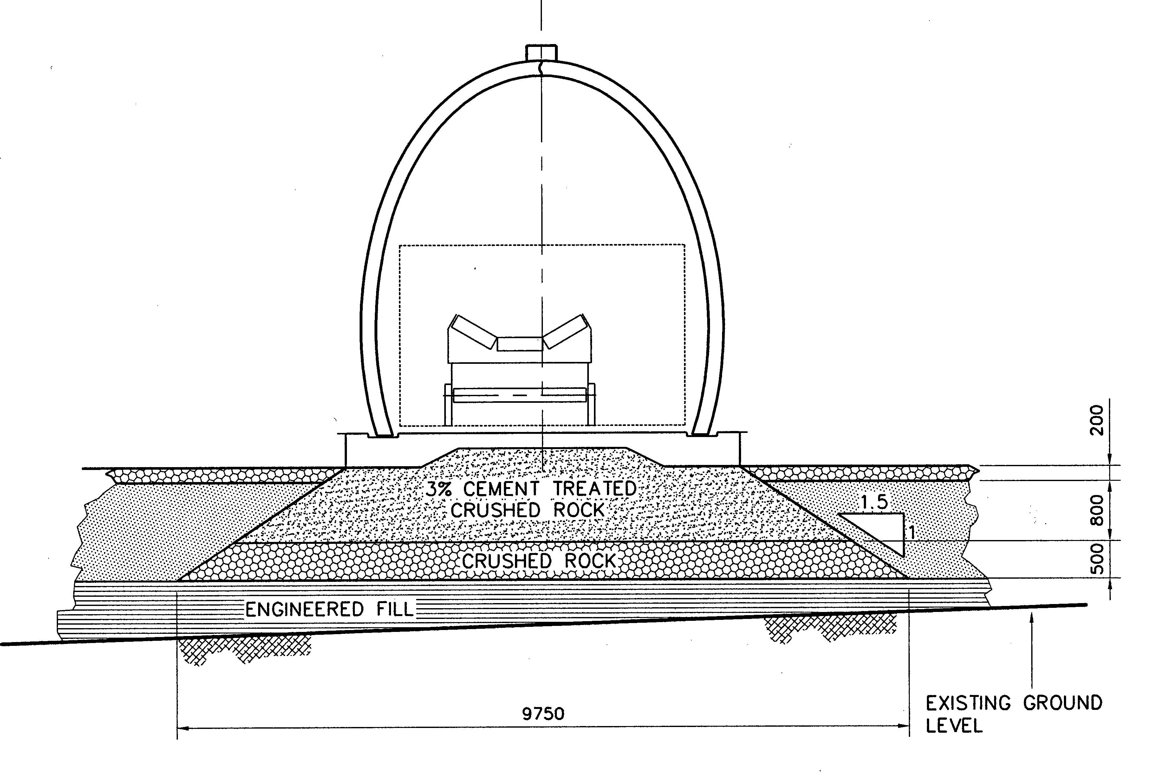
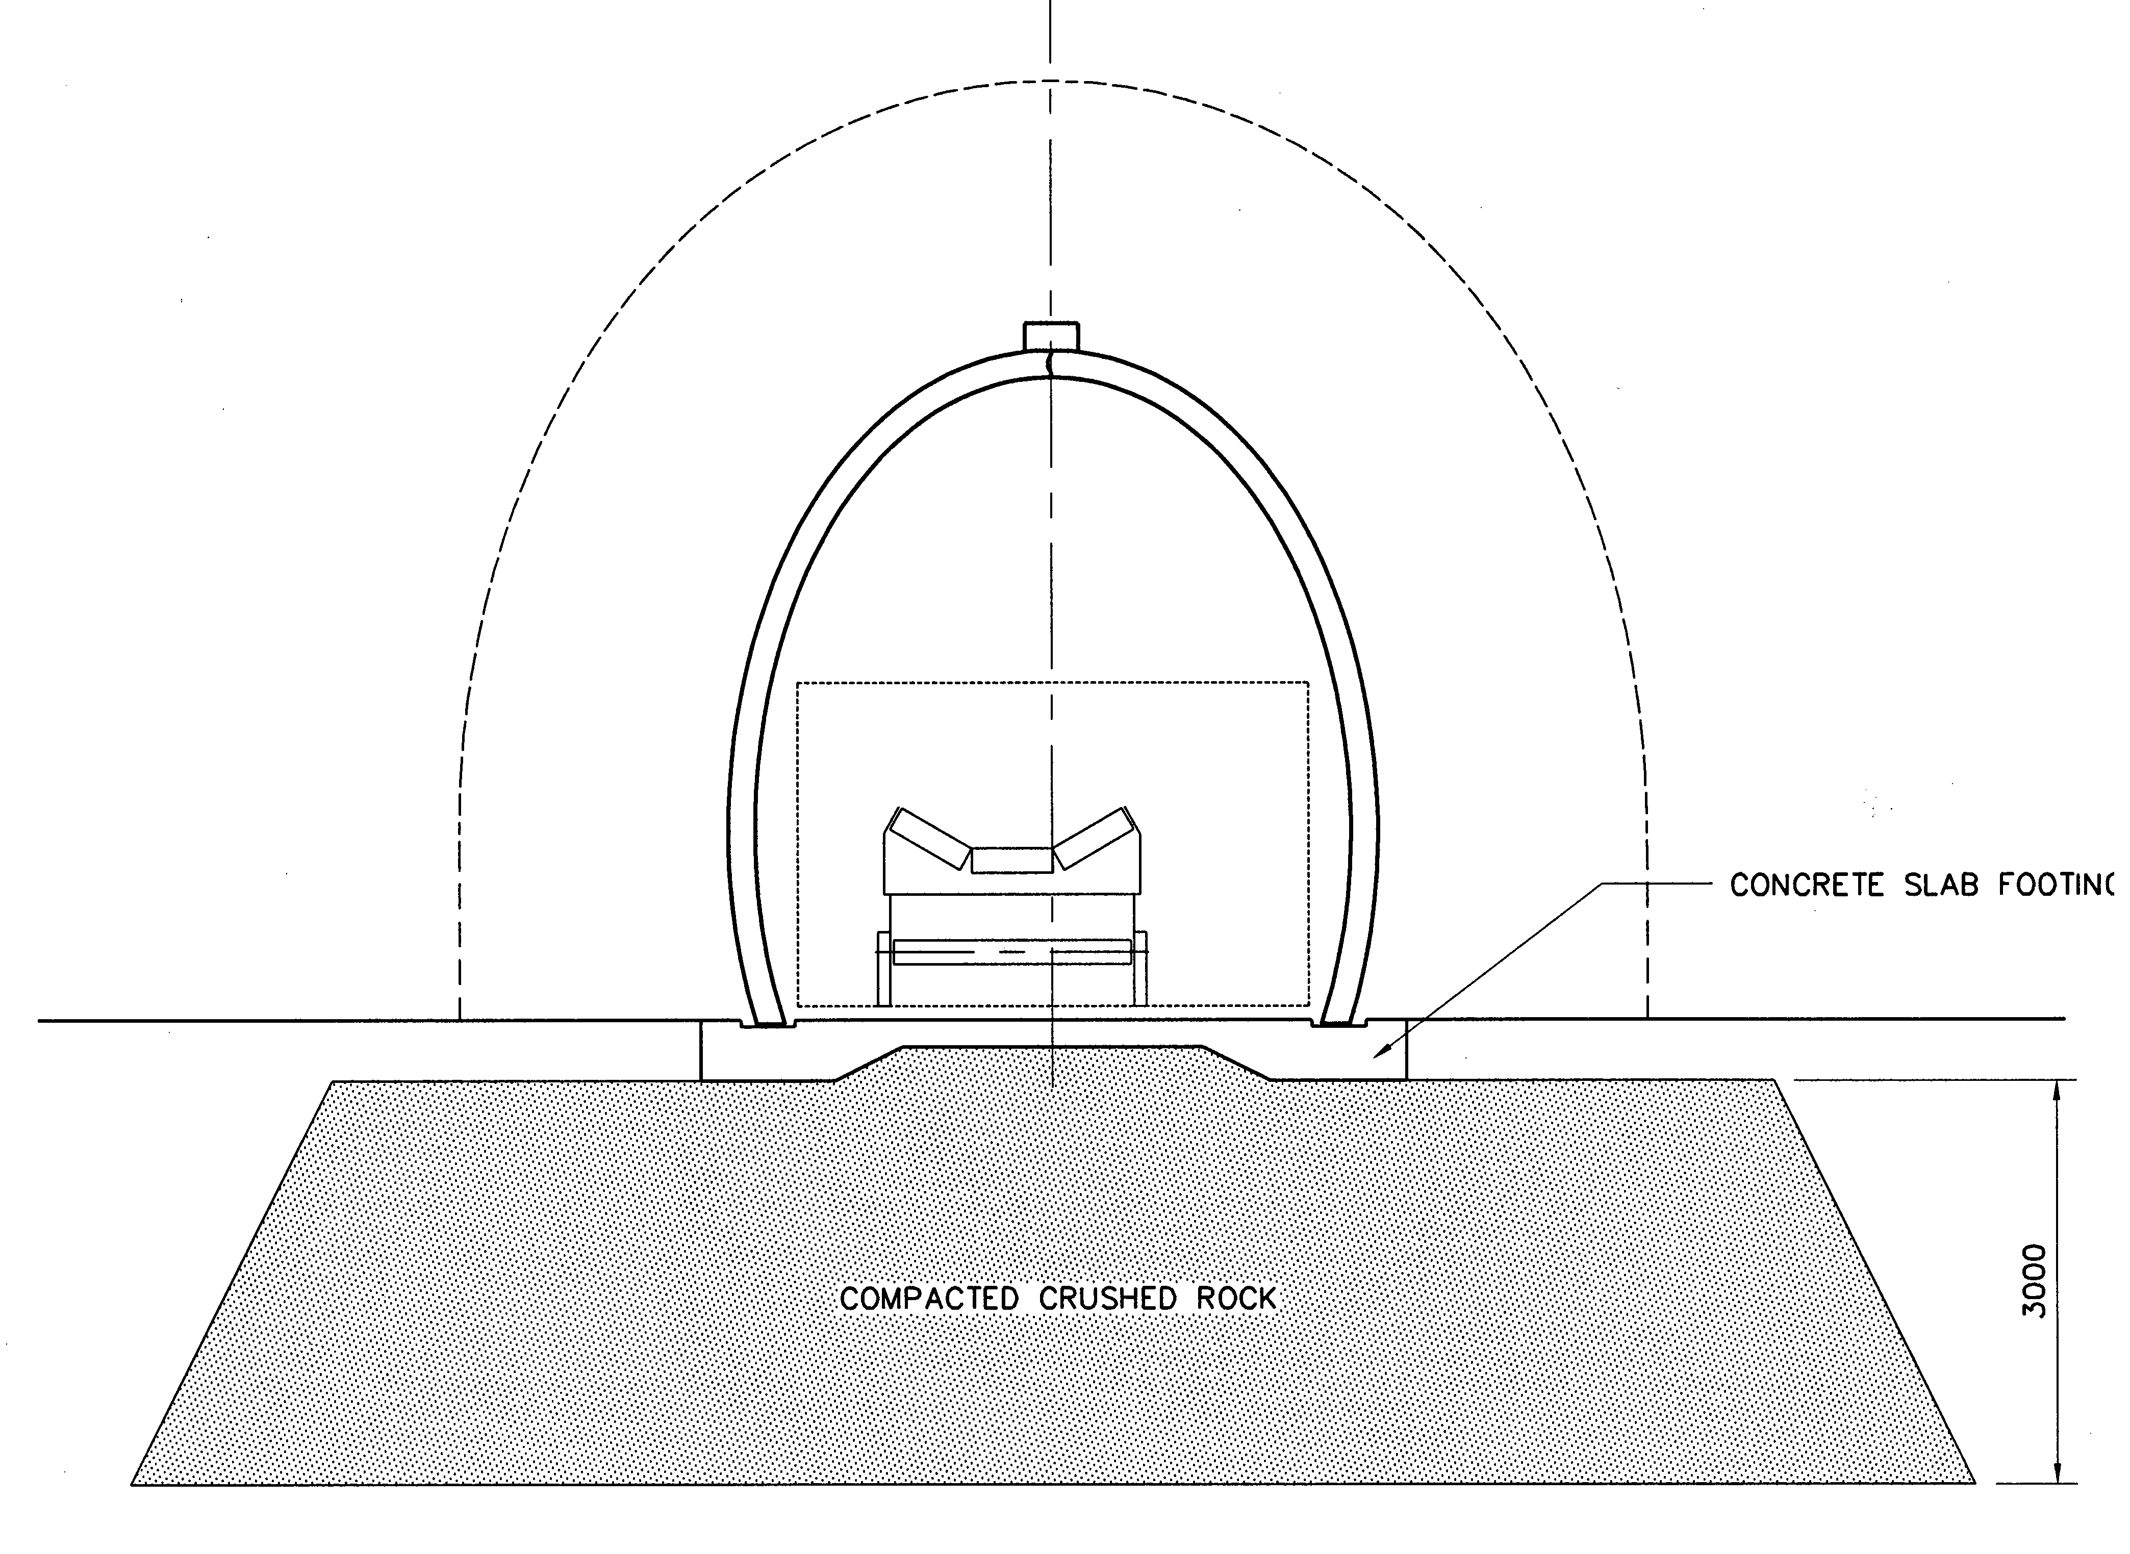
Fig.10a & b Alternative raft slab details
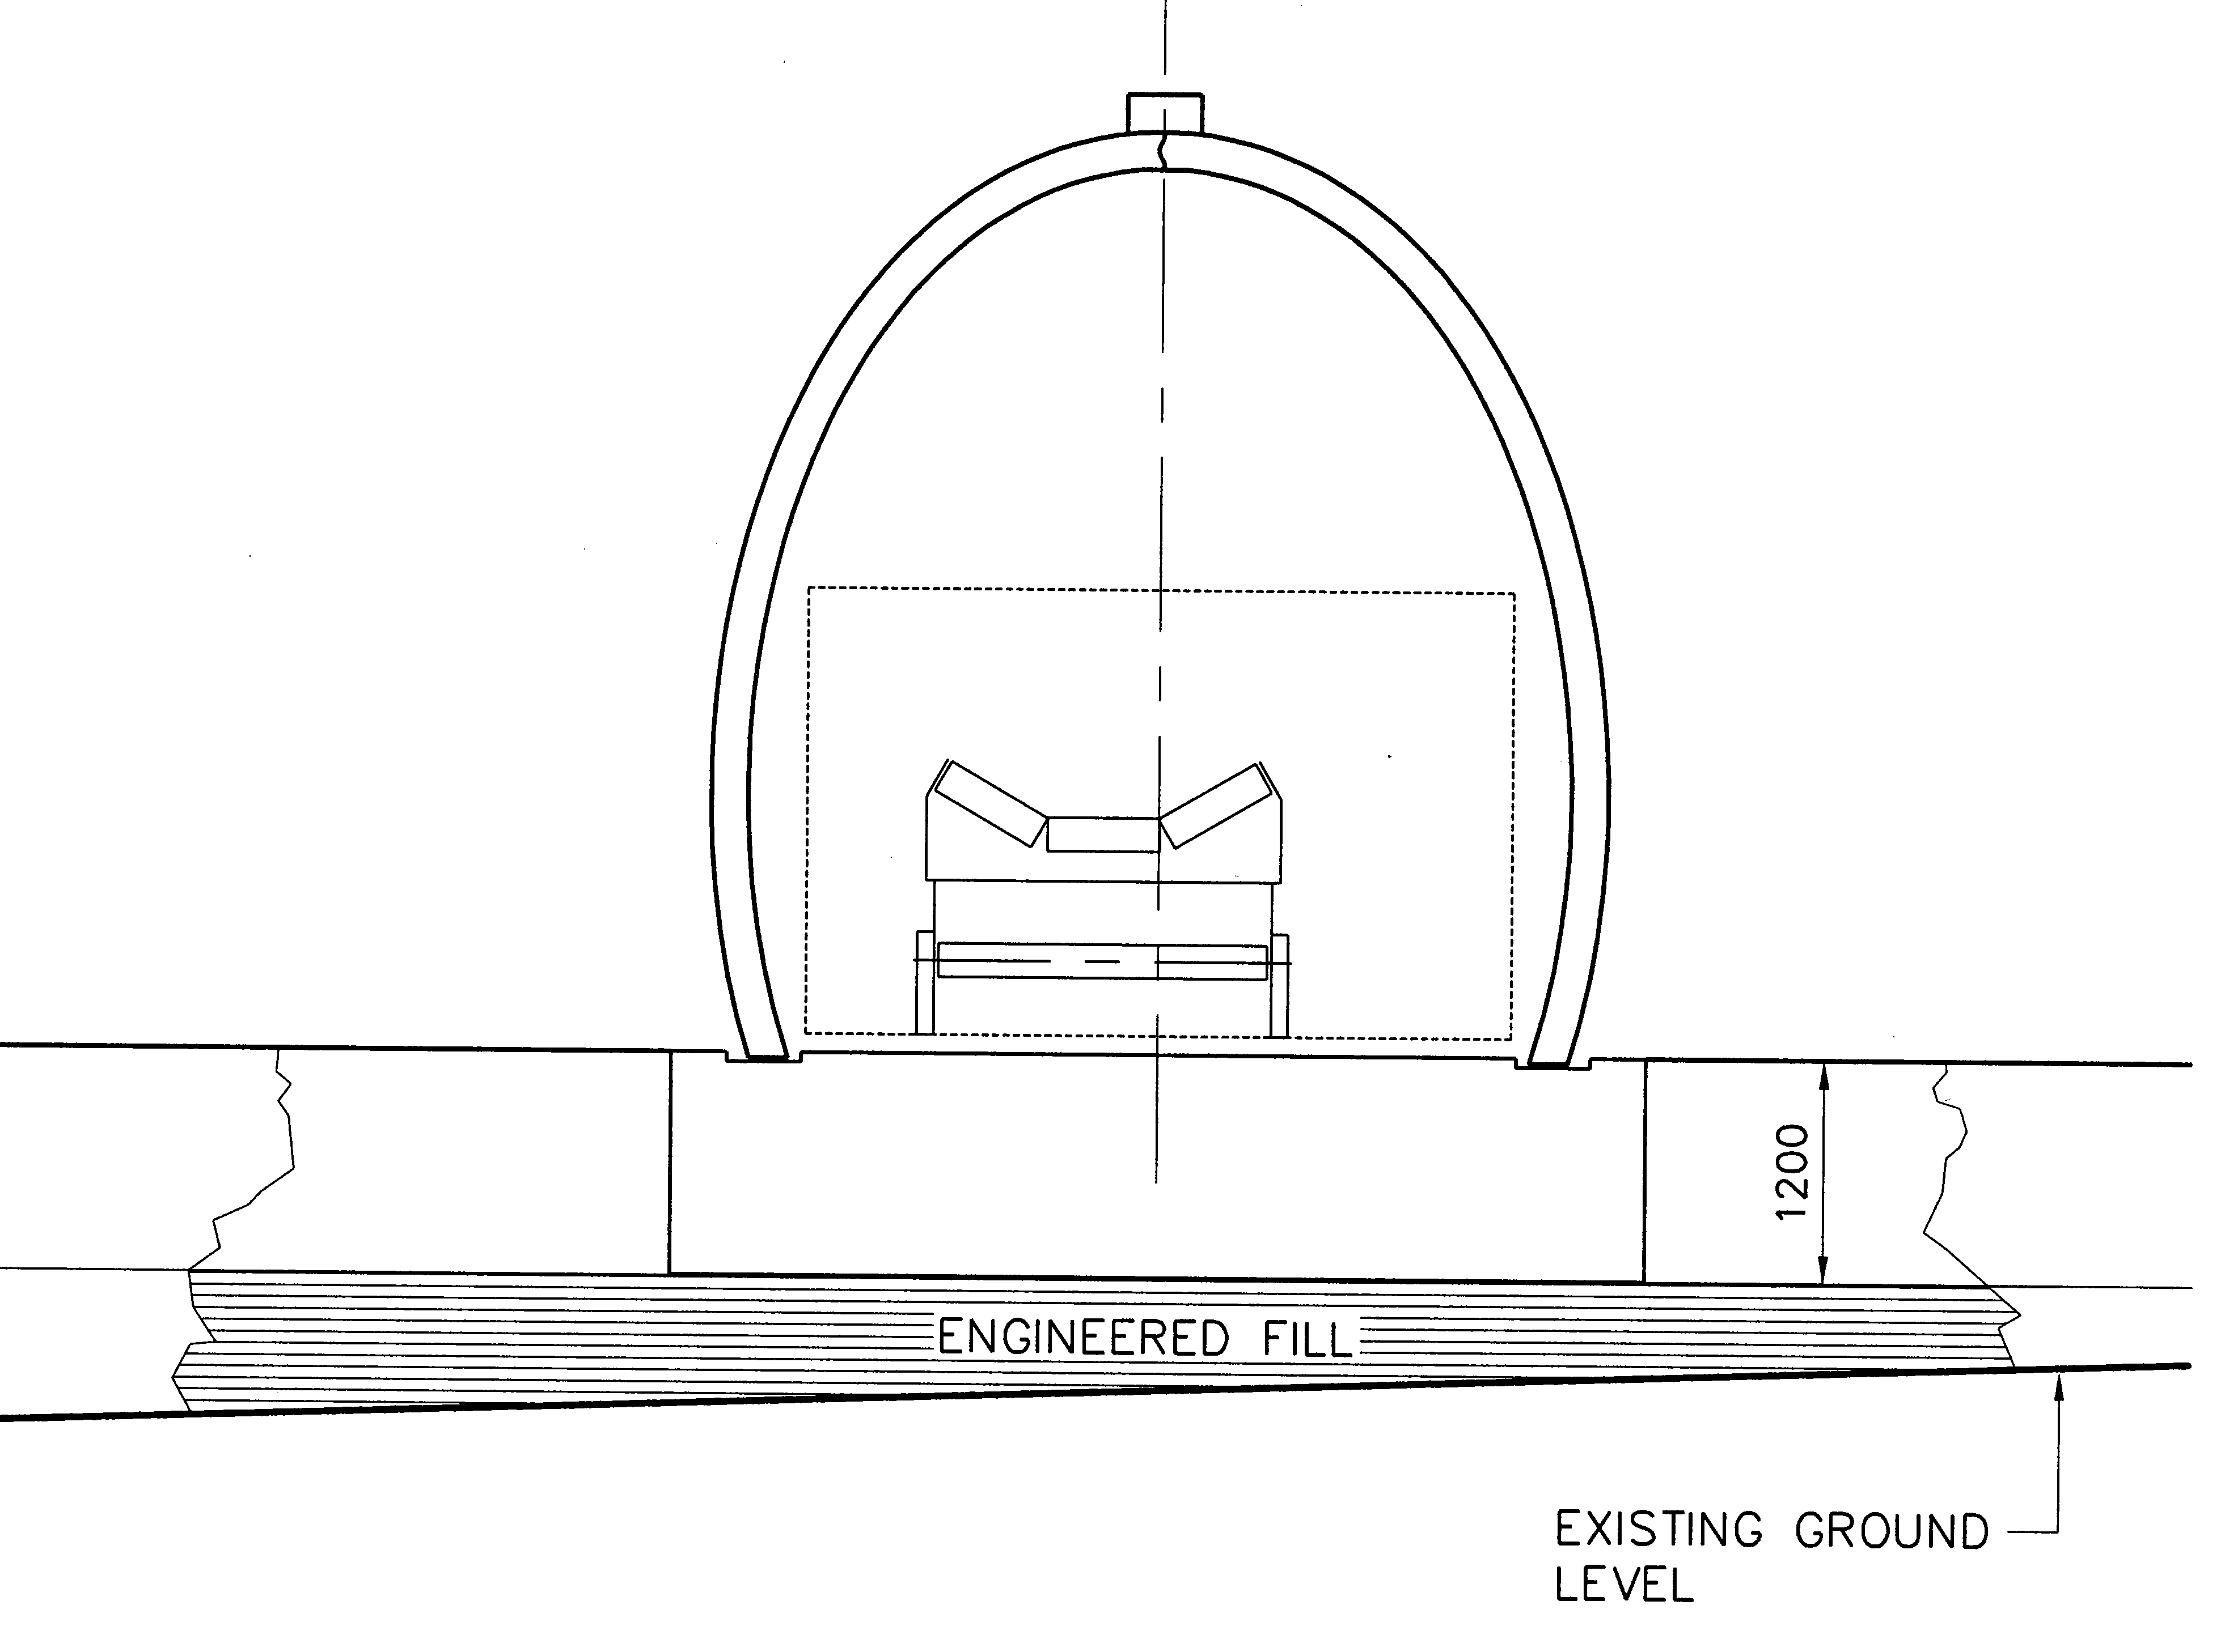
Fig.11 Flat Raft Slab Details
Fig. 12 Raft forces, Type A Raft

Fig. 13 Raft forces, Type B Raft

Fig. 14 Raft bending Moments, Flat raft

Fig.15 Raft Bending Moment, alternative analysis methods

Fig.16 Raft Shear Forces. Alternative analysis methods

Fig.17 Raft Axial Forces, alternative analysis methods

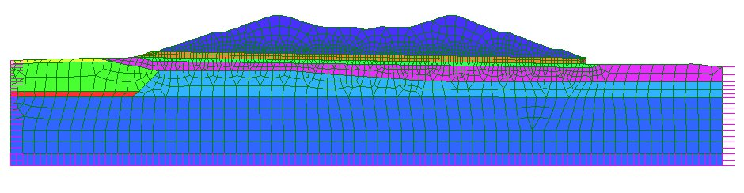

Fig.18 Longitudinal FEA mesh diagram

Fig. 19 Settlement and Longitudinal Movement; minimum stiffness
Fig. 20 Settlement and Longitudinal Movement; maximum differential stiffness

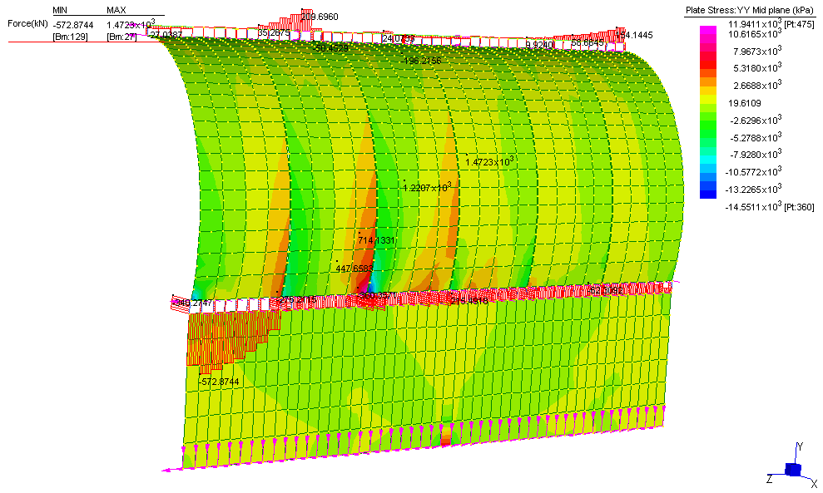
Fig. 21 3D Longitudinal analysis

LONGITUDINAL ANALYSIS

A detailed longitudinal analysis of the tunnels and embankment was required to assess the following effects:

- Differential settlement due to varying foundation conditions.
- Longitudinal strain of the arch and foundations due spreading of the underlying soils under the weight of the embankment.
- Longitudinal overturning loads on the arch segments due to the embankment slope.

The following design features were provided to accommodate longitudinal effects:

- Wide co-incident movement gaps in the arch and raft slabs at 12 metre intervals to allow for rotation and longitudinal strains.
- Intermediate joints in the longitudinal crown beam to the arch provided additional flexibility, whilst maintaining the stability of the arch to longitudinal forces.
- The vertical alignment of the arch was preset in the mid-range of the predicted settlements to avoid sags in the conveyor alignment after completion of settlement.

Independent 2D longitudinal analyses were carried out by Reinforced Earth, using Strand7, and by SMEC, using FLAC. Agreed lower and upper bound soil stiffness parameters were used, based on soil investigation reports, and settlement results from large trial embankments. Each section was analysed using lower and upper bound stiffness values, to determine the likely range of settlement, and using maximum differential stiffness (i.e. maximum coal stiffness and minimum fill stiffness) to determine the maximum differential settlement. In addition Reinforced Earth carried out 3D analyses of the arch and raft slab to assess the effect of differential settlement and longitudinal strains on the structure.

A typical finite element mesh for the longitudinal analysis is shown in Figure 18. The section analysed was adjacent to the conveyor tunnels, ignoring the stiffening effect of the structure. The soil elements at the level of the structure were modelled as rectangular elements with the same elevation dimensions as the precast arch panels. The soil strains at the corners of the elements were then extracted and used to calculate joint opening and closing, and stresses in the structure, assuming that all strains took place at the movement joints. Anticipated settlements and longitudinal movements are shown in Figure 19 for the minimum stiffness parameters, and in Figure 20 for the maximum differential stiffness. Figure 21 shows a typical 3D analysis of the arch structure, subject to the strains extracted from the 2D analysis.

CONCLUSIONS

The design of precast arch tunnels under very high fills used numerical analysis of soil-structure interaction effects to achieve significant savings in materials, and to verify the performance of the structure under severe differential settlement conditions:

- The cross section profile of the arch was optimised to minimise bending moments and shear forces in the finished structure. As a result, long term reinforcement stresses are very low, minimising crack widths and aiding durability.
- Use of a raft slab of varying section, together with improvement of the foundation fill stiffness immediately under the raft, enabled a substantial reduction in the depth of the raft.
- The effect of differential settlement and longitudinal forces on the structure and on joint movements was checked for a range of assumed soil stiffness parameters.
- Two separate finite element analyses of the complete embankment and foundation gave good agreement for all forces in the raft slab. A simplified analysis using plate elements on elastic supports gave good agreement for bending moments and shear forces when the support stiffness was set to match the total settlement found in the analyses of the full system. The axial forces found in the simplified analysis were not in good agreement with the other analyses.

