Soil Loads on Cut and Cover Tunnels Under High Fills

Doug Jenkins
Interactive Design Services Pty Ltd Hornsby, NSW, Australia

ABSTRACT

In recent years precast concrete arches have been increasingly popular for use in applications such as drainage culverts, conveyor tunnels, rail and road tunnels, and alternatives to short span bridges. The design of these structures for fill heights greater than about 10 metres over the crown presents potential problems that require experience and careful analysis to resolve. These include:

- High axial loads and shear forces that may be sensitive to the stiffness parameters of the foundation and backfill materials.
- Design of foundation structures for high vertical loads.
- Longitudinal differential settlement.
- Longitudinal loads on the structure due to steep fill slopes, inclined structural elements, and longitudinal spreading of the foundations.

In this paper examples are given of structures that have exhibited these problems, and design methods are presented that will ensure that problems will be avoided. Examples are presented of successful projects in Australia and overseas, with fill heights of up to 50 metres over the structure.

1 Introduction

Buried precast concrete arch structures are widely used in applications such as drainage culverts, conveyor tunnels, rail and road tunnels, and alternatives to short span bridges. They are often particularly advantageous in conditions where high vertical loads would necessitate the use of very thick concrete members in rectangular sectioned structures. Use of an appropriate arch profile enables bending moments to be minimised, and much thinner sections to be used; however where the fill height exceeds about 10 metres over the crown of the arch, the fill loads present potential design problems that require experience and careful analysis to resolve. These include:

- High fills always induce high axial loads in a concrete arch, and may give rise to high bending moments and shear forces if the shape of the structure has not been properly optimised. The magnitude of these forces may be sensitive to the stiffness parameters of the foundation and backfill materials and the profile of the arch.
- Design of raft slabs for high vertical loads on soil foundations requires careful choice of the slab geometry, analysis of worst case foundation conditions, and control of fill compaction.
- Special provisions may be required to accommodate longitudinal differential settlement.
- Longitudinal loads on the structure due to steep fill slopes, inclined structural elements, and longitudinal spreading of the foundations require consideration.

This paper describes examples of structures where these factors have significantly affected the design, or have caused problems during construction or in service. Design and analysis procedures are presented that will ensure that problems will be avoided and examples are presented of successful projects in Australia and overseas, with fill heights of up to 50 metres over the structure.

2 The Influence of High Fills on Structural Actions

Unlike bored tunnels and flexible buried structures, the total axial load at the base of a buried concrete arch is normally equal to or greater than the weight of fill vertically above the maximum plan width of the arch. The axial load may be significantly affected by the stiffness of the foundation materials and the type of foundation structure. To illustrate the effect of these factors a series of finite element analyses have been carried out on two actual structures under high fills. Figure 1 shows the axial load at the base of a 5 metre span arch under 40 metres of fill at the Morwell Power Station in Victoria. The elastic modulus of the foundation material has been varied between 10 MPa and 500 MPa, and three alternative foundation arrangements have been considered. In the actual structure a 2 or 3 metre thick pad of crushed rock or cement treated sand was provided under a raft foundation. For the purposes of illustration the stiffness of this material has been varied as follows:

- Spread footings on a soft material (E = 20 MPa)
- Raft foundation on a soft material (E = 20 MPa)
- Raft foundation on a stiff material (E = 200 MPa)

The weight of fill vertically above the arch half width was 1830 kN. It can be seen that the axial load in the arch was increased above this value by a factor varying between about 1.0 and 1.7. The loads in the actual structure, which was founded on deep deposits of soft brown coal, were close to the maximum value found in this study.

Figure 1: Effect of foundation stiffness and footing type on axial load
Figure 2: Effect of foundation stiffness on shear force and bending moments

The foundation stiffness may also have a significant effect on bending moments and shear forces in the arch, particularly where the arch shape has not been optimised for high fills. Figure 2 shows the maximum shear forces and bending moments in an arch structure that failed in shear after several years in service. The arch had a flat aspect ratio and a fill height of 20 metres, with a rock foundation of variable quality. In this case the better quality rock has resulted in significantly higher shear forces and bending moments, because a higher proportion of the shear force has been transferred to the base, rather than being transferred into the fill around the arch.

In order to make adequate allowance for the effect of foundation conditions on forces in structures under high fills it is necessary to:

- Carry out a finite element analysis, modelling the foundation materials as well as the arch and fill.
- Extend the finite element model to a sufficient distance so that boundary conditions do not affect the results. For structures founded on compressible material the foundation soils should be modelled to a depth of at least twice the height of fill, or to a relatively incompressible layer. The edge of the model should be outside a line extending at 45 degrees from the back of the arch footing up to the final fill surface.
- Consider the effect of upper and lower bound stiffness values in the foundation materials.
- Model the footing structure accurately.

3 Design of foundation structures for high vertical loads

Where structures are founded on high strength rock the design of strip footings is straightforward, however loads on soil or weak rock foundations will often be too high to allow the use of strip footings, and raft foundations are often an economic alternative. Under very high fills high bending moments are generated in flat raft slab foundations, resulting in very thick, stiff slabs, which will increase the bending moments still further. Use of slabs with a varying cross section, combined with improvement of the foundation soils where necessary, can significantly reduce design bending moments, and result in a much more efficient section.

An example of a successful implementation of structures of this type is the Morwell Power Station, where arch structures were used to carry four conveyors under a new embankment of up to 40 metres height. In order to reduce bending moments, the slab was reduced in depth over the central section, and fill material of higher stiffness was used under the slab. The combined slab and fill in effect acted as a deep beam, with the slab acting as a tension member. Different details were used in the final design (Figure 3), due to availability of suitable fill materials, weather conditions, and time constraints.

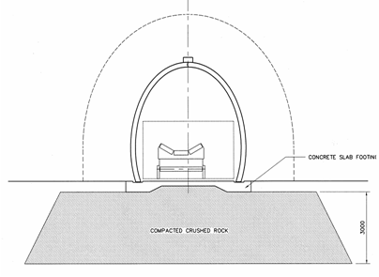 | 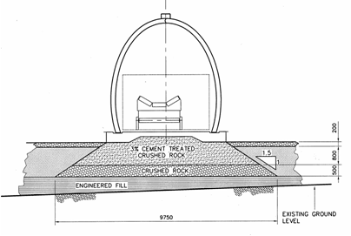
Figure 3: Morwell Conveyor Tunnels; Alternative foundation treatments to raft slab

The raft foundation slab and the arch were modelled in the same finite element analysis, including the underlying layers of brown coal and clay. The main analysis was carried out using in-house software developed by the arch supplier, The Reinforced Earth Company. In addition the analysis was checked with a second finite element analysis of the complete arch and slab system, using Strand7, and also with a simpler model using elastic support elements. The models used for the
Figure 4: Strand7 model of arch and slab (detail) | Figure 5: Simplified raft slab model

Figure 6: Raft bending, shear, and axial loads | Figure 7: Comparison of flat and tapered raft bending

Figure 8: Alternative analysis methods; Bending | Figure 9: Alternative analysis methods; Shear forces
Figure 10: Alternative analysis methods; Axial forces
alternative analyses are shown in Figures 4 and 5. The simplified model used plate elements to model the stiffer fill immediately under the raft, with elastic supports to the plates to model the foundation layers. The elastic stiffness of these supports was determined so that the total settlement of the raft slab was equal to that found in the finite element analyses.

Typical bending moment and shear and axial force diagrams for the maximum fill height are shown in Figure 6. Figure 7 compares the bending moments from the adopted design with a flat slab design with unimproved foundations. Increased bending moments and shear forces required the flat slab depth to be increased to 1200 mm. The increased stiffness of the slab reduces the effect of soil-structure interaction, resulting in a very high bending moment of 1500 kNm at the centre of the slab.

The results of the three different methods of analysis are shown in Figures 8 to 10. It can be seen that there is good agreement between the three analyses for bending moments and shear forces, but the simplified analysis results for axial force are significantly different. This would be expected, since the stiffness of the supports in the simplified analysis was chosen to give the same vertical settlement as the full analyses, but the simplified model does not model the horizontal restraint on the foundation soils, or the effect of the overburden pressure outside the plan extent of the raft.

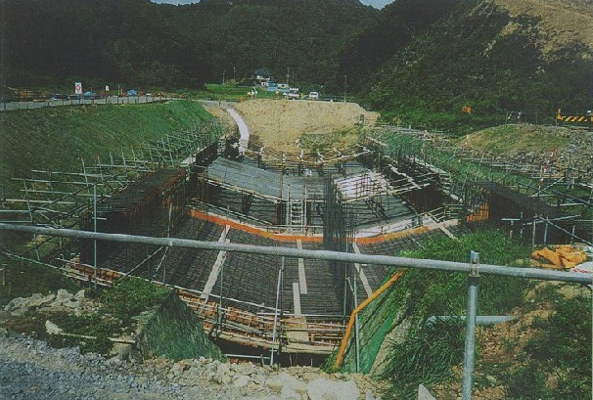
Figure 11: A deep trough raft slab in Japan that developed severe cracking during backfilling

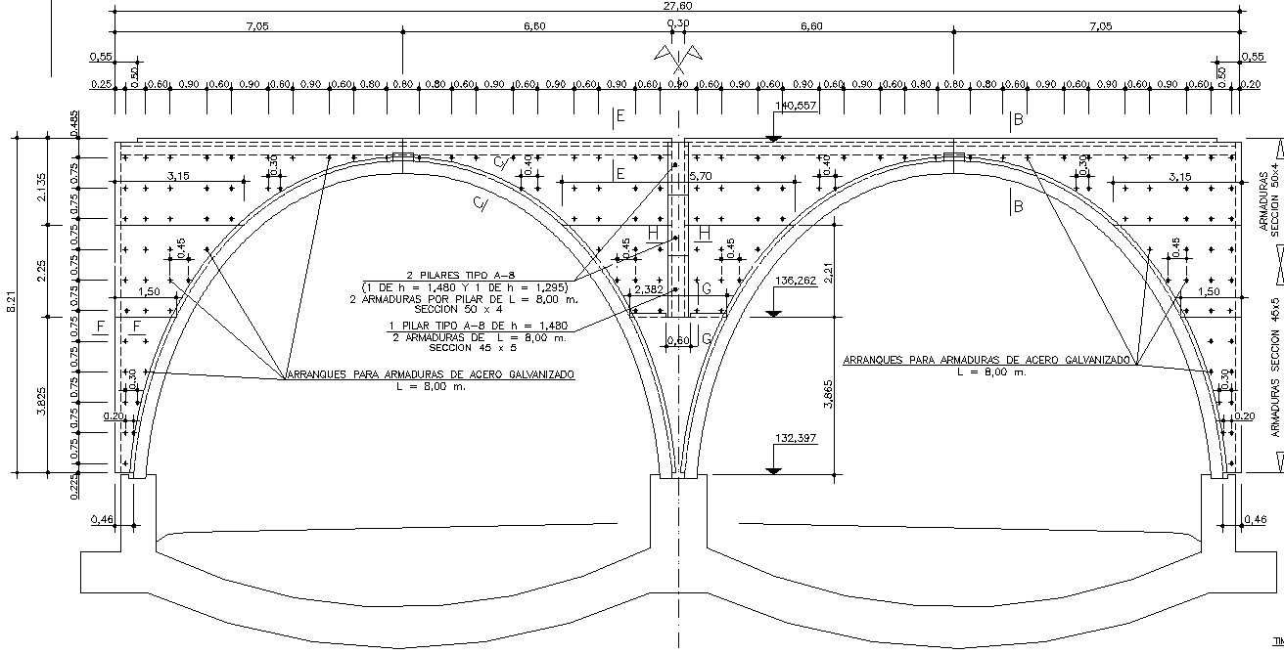
Figure 12: Inverted arch raft slab used successfully in Spain

For larger span arches (greater than about 8 metres span) use of flat or tapered raft foundations may not be economic. Alternatives that have been used include arched foundation slabs and trough structures with inclined base slabs. For structures of this type it is essential that the restraint to horizontal deflection of the slab achieved on site is at least equal to that assumed in the design. Figure 11 shows an example of a structure that suffered severe cracking due to high bending moments in the base, in spite of the use of a slab depth of approximately 2 metres, and very heavy transverse reinforcement. The high bending moments in the base of the structure are believed to have been caused by a combination of inadequate compaction of the fill behind the vertical faces of the base, and a layer of very soft soil beneath the structure causing differential settlement.

Figure 12 shows a cross section of an arch base slab design used successfully in Spain. This twin arch has a span of 12.6 m, a height of 7.5 m, and a fill height of 32 m.

4 Longitudinal differential settlement

Structures under high embankments may be subject to large differential settlements along the length of the structure due to the variations in the vertical loads and foundation materials. At the Morwell Power Station conveyor tunnel the brown coal layers beneath the structure extended to a depth of up to 80 metres, resulting in maximum predicted differential settlements of over 1.5 metres. The potential differential movement problem was increased by the presence of uncompacted fill of variable depth at one end of the structures.

Independent 2D longitudinal analyses were carried out by Reinforced Earth, using Strand7, and by SMEC, using FLAC. Agreed lower and upper bound soil stiffness parameters were used, based on soil investigation reports, and settlement results from large trial embankments. Each section was analysed using lower and upper bound stiffness values, to determine the likely range of settlement, and using maximum differential stiffness (i.e. maximum coal stiffness and minimum fill stiffness) to determine the maximum differential settlement. In addition Reinforced Earth carried out 3D analyses of the arch and raft slab to assess the effect of differential settlement and longitudinal strains on the structure.

Fig.13: Morwell Conveyor Tunnels, Longitudinal FEA mesh

A typical finite element mesh for the longitudinal analysis is shown in Figure 13. The section analysed was adjacent to the conveyor tunnels, ignoring the stiffening effect of the structure. The soil elements at the level of the structure were modelled as rectangular elements with the same elevation dimensions as the precast arch panels. The soil strains at the corners of the elements were then extracted and used to calculate joint opening and closing, and stresses in the structure, assuming that all strains took place at the movement joints. Anticipated settlements and longitudinal movements are shown in Figure 14 for the minimum stiffness parameters, and in Figure 15 for the maximum differential stiffness. Figure 16 shows a typical 3D analysis of the arch structure, subject to the strains extracted from the 2D analysis

Figure 14: Morwell Conveyor Tunnels, predicted settlement with minimum foundation stiffness. | Figure 15: Morwell Conveyor Tunnels, predicted settlement with maximum differential foundation stiffness.

The following design features were provided to accommodate longitudinal effects:

- Wide co-incident movement gaps in the arch and raft slabs at 12 metre intervals to allow for rotation and longitudinal strains.
- Intermediate joints in the longitudinal crown beam to the arch provided additional flexibility, whilst maintaining the stability of the arch to longitudinal forces.
- The vertical alignment of the arch was preset in the mid-range of the predicted settlements to avoid sags in the conveyor alignment after completion of settlement.

The preset in the vertical alignment can be seen in Figure 17, and Figure 18 shows the arrangement of movement joints and the crown beam.

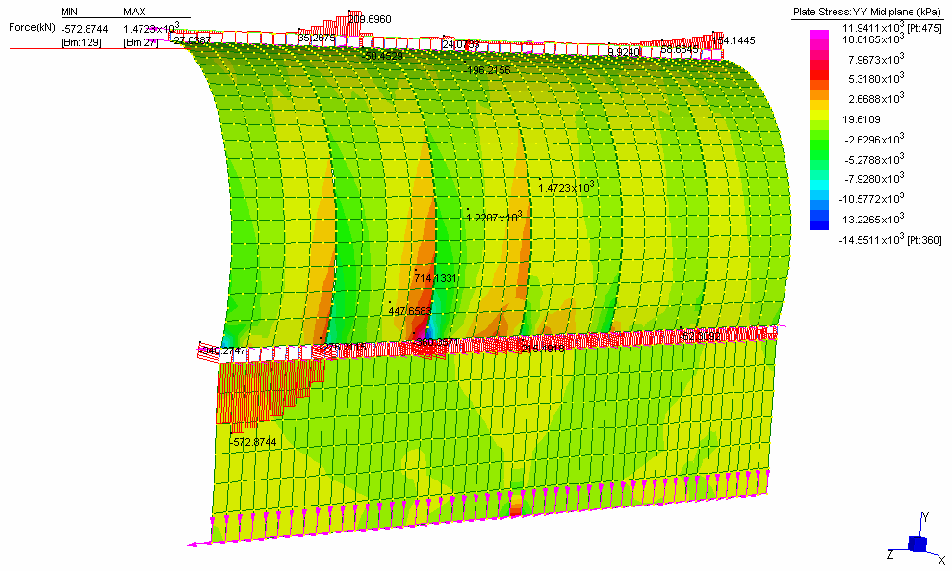
Figure 16: Morwell Conveyor Tunnels, typical 3D analysis

5 Longitudinal Loads

Longitudinal loads on buried structures may arise from a variety of sources:

- Steep fill slopes above the structure.
- Segmental structures constructed on steep slopes.
- Longitudinal spreading of foundations under high fills.
- Longitudinal differential settlement effects on continuous structures.

A number of buried arch structures in Japan and North America have suffered significant structural problems due to these loads, including:

- Spalling of arch crown joints.
- Inclined tension cracks at the base of arch elements.
- Differential twisting movement at the crown

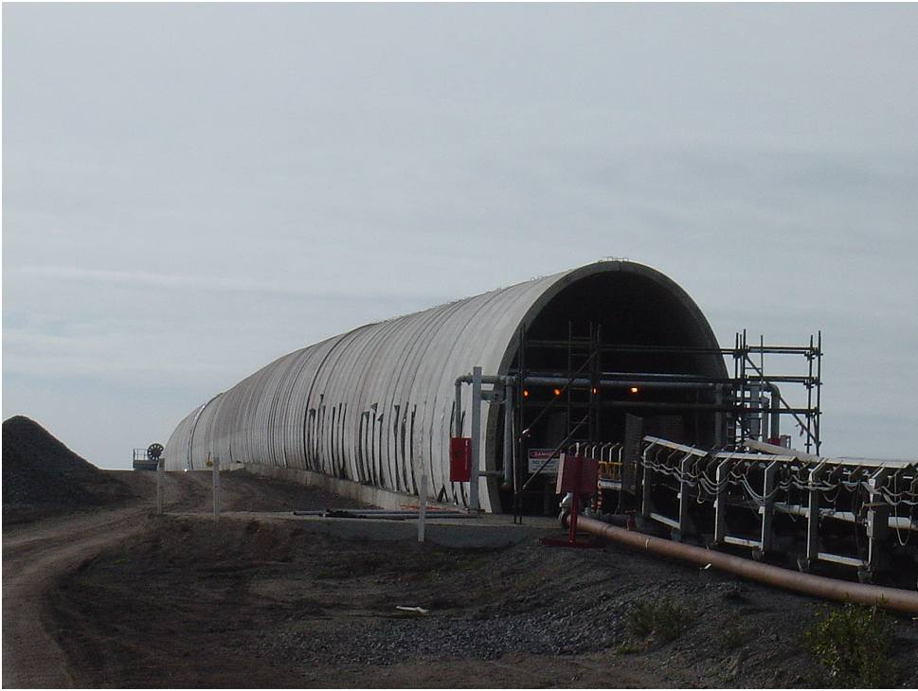 | 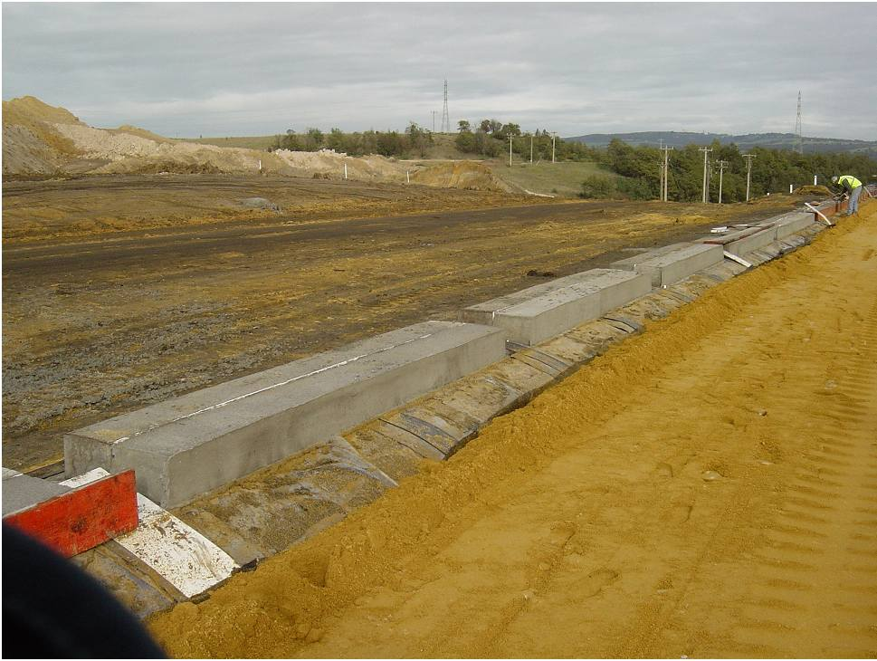
Figure 17: Morwell Conveyor Tunnels, vertical alignment preset | Figure 18: Morwell Conveyor Tunnels, movement joints and crown beam.
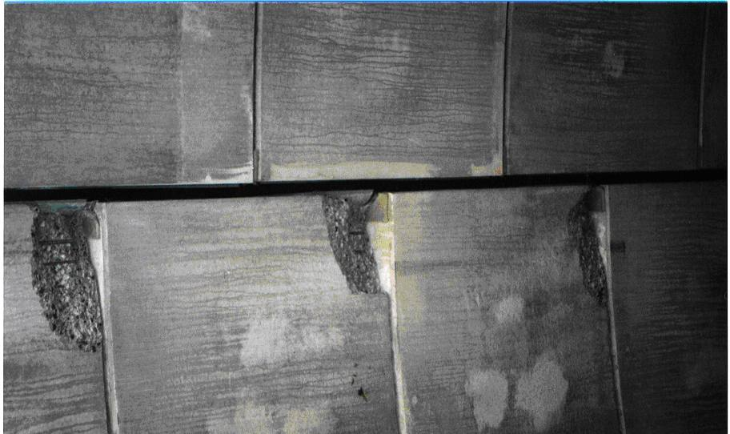
Figure 19: Spalling due to longitudinal loads in Japanese arch structure

Figure 19 illustrates a typical example of spalling at the arch crown due to twisting of the arch elements caused by longitudinal loads. Problems associated with longitudinal loads may be avoided by careful analysis of the magnitude and effect of the loads and by taking appropriate measures to either resist the loads or allow movements to take place without adverse affect on the structure. Measures that may be taken where necessary include:

- Use wider precast elements.
- Provide shear connectors between adjacent elements and/or strengthen the crown beam.
- Provide movement joints in the crown beam and footings.
- Design arch reinforcement taking account of the variation in axial load due to longitudinal loads.
- Detail crown joints to avoid un-reinforced edges likely to spall if subject to torsional loads.

6 Examples of arches under high fills

In addition to the Morwell Power Station conveyor tunnels (Figures 17, 18) a number of conveyor tunnels and mine access tunnels have been constructed in Australia, with fill heights of up to 35 metres. In addition to high vertical loads, conveyor tunnels under stockpiles are also subject to high asymmetric loading when the stockpile is drawn down on one side only, and this is often the critical design load.

Internationally, arches are frequently used for drainage culverts and minor roads under high embankments. This use is particularly common in Spain, where arches with fill heights up to 50 metres have been constructed (Figures 20, 21). Larger arches have also been constructed in Spain as cut and cover road tunnels, with fill heights of over 30 metres. Figure 22 shows a typical twin arch road tunnel in Spain. A similar structure, designed in Australia, is now under construction in Korea with twin 15 metre spans and over 20 metres fill height.

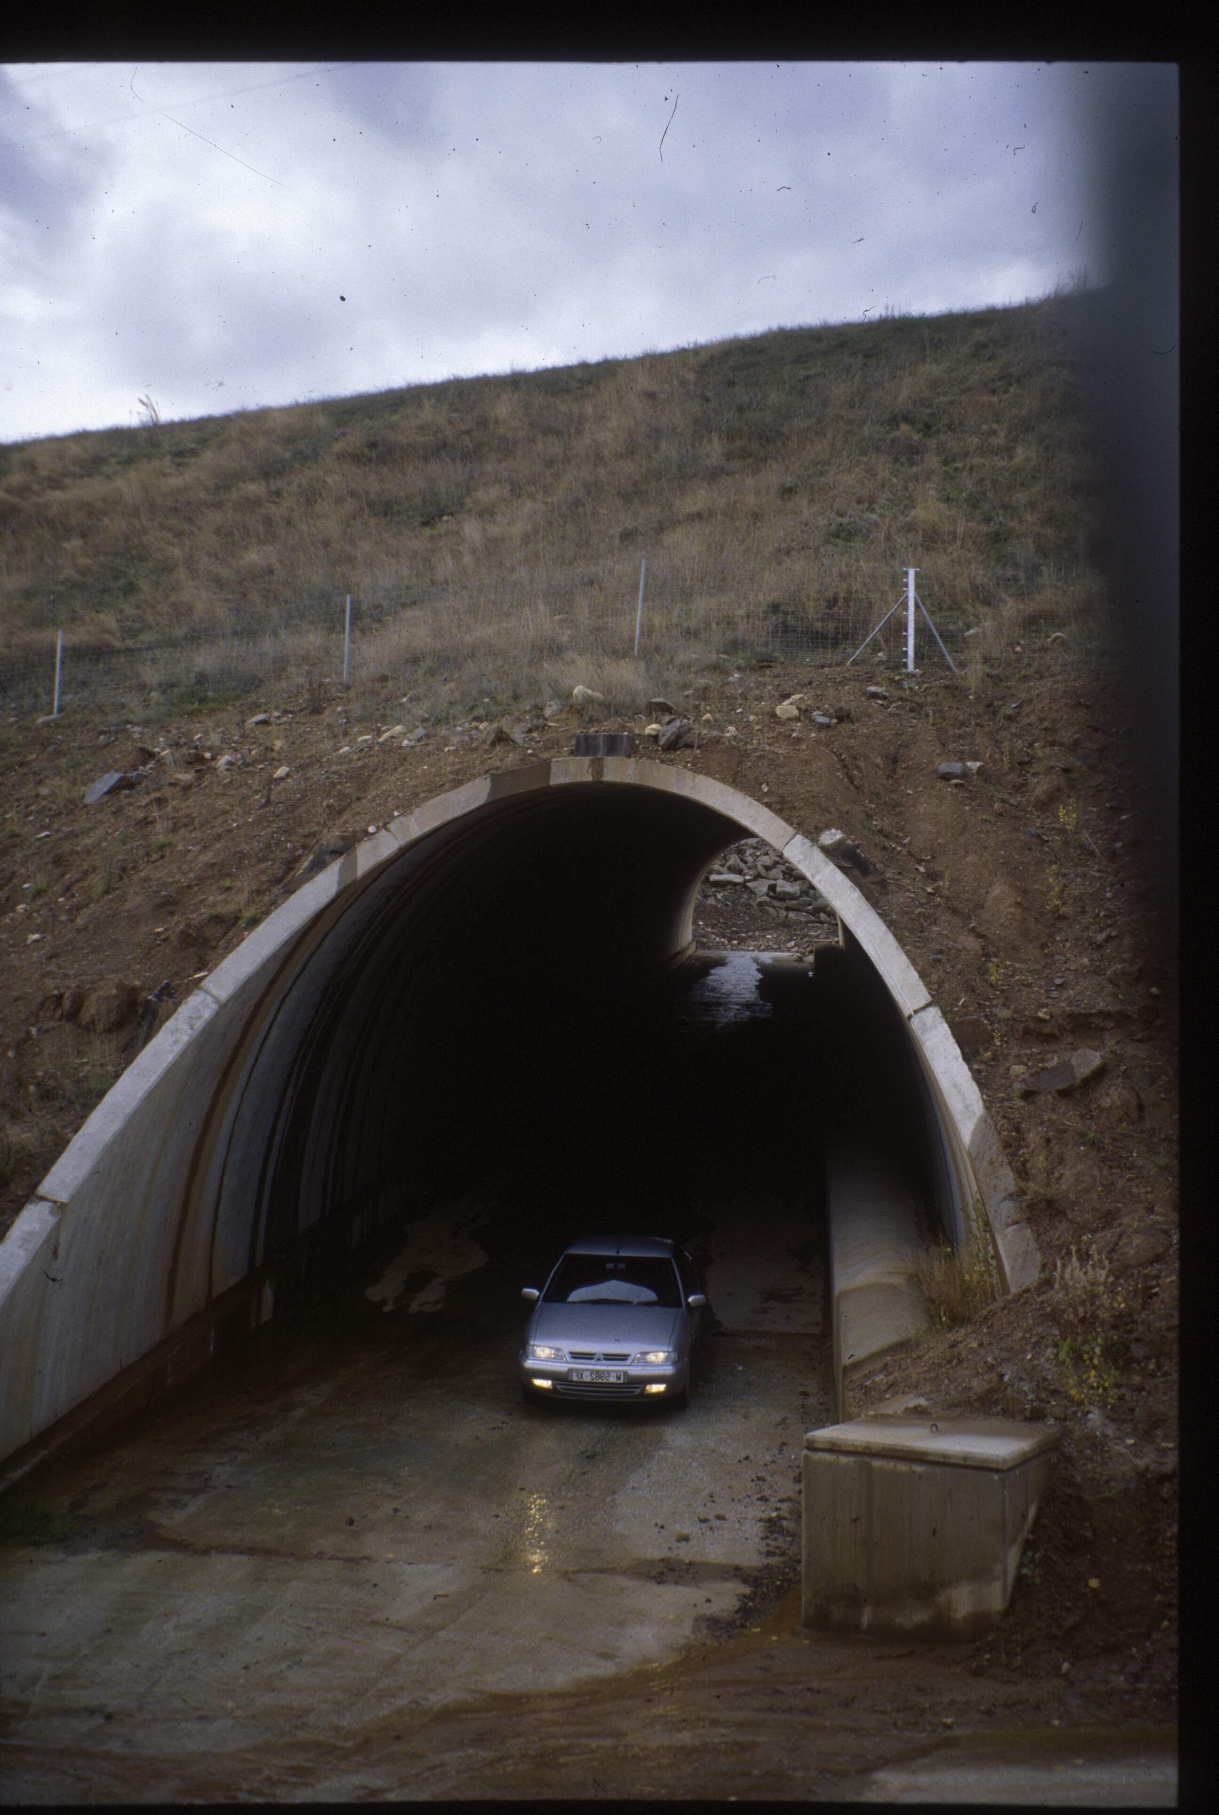 | 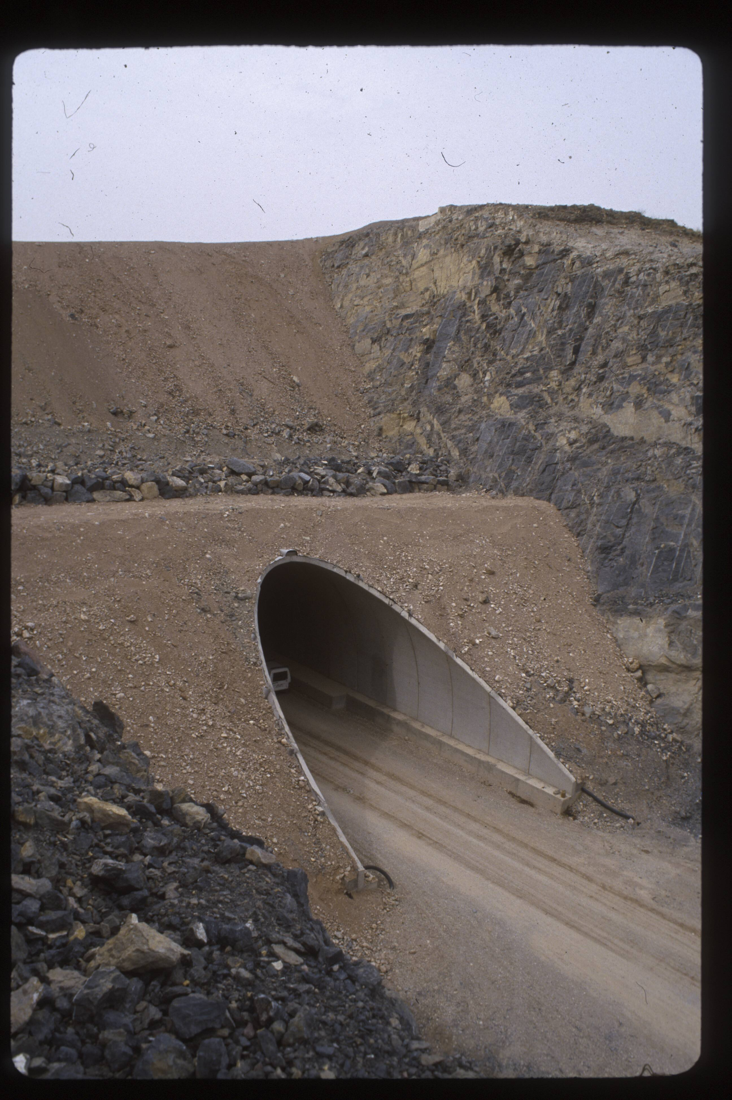
Figures 20, 21: Typical arch structures under high fills in Spain

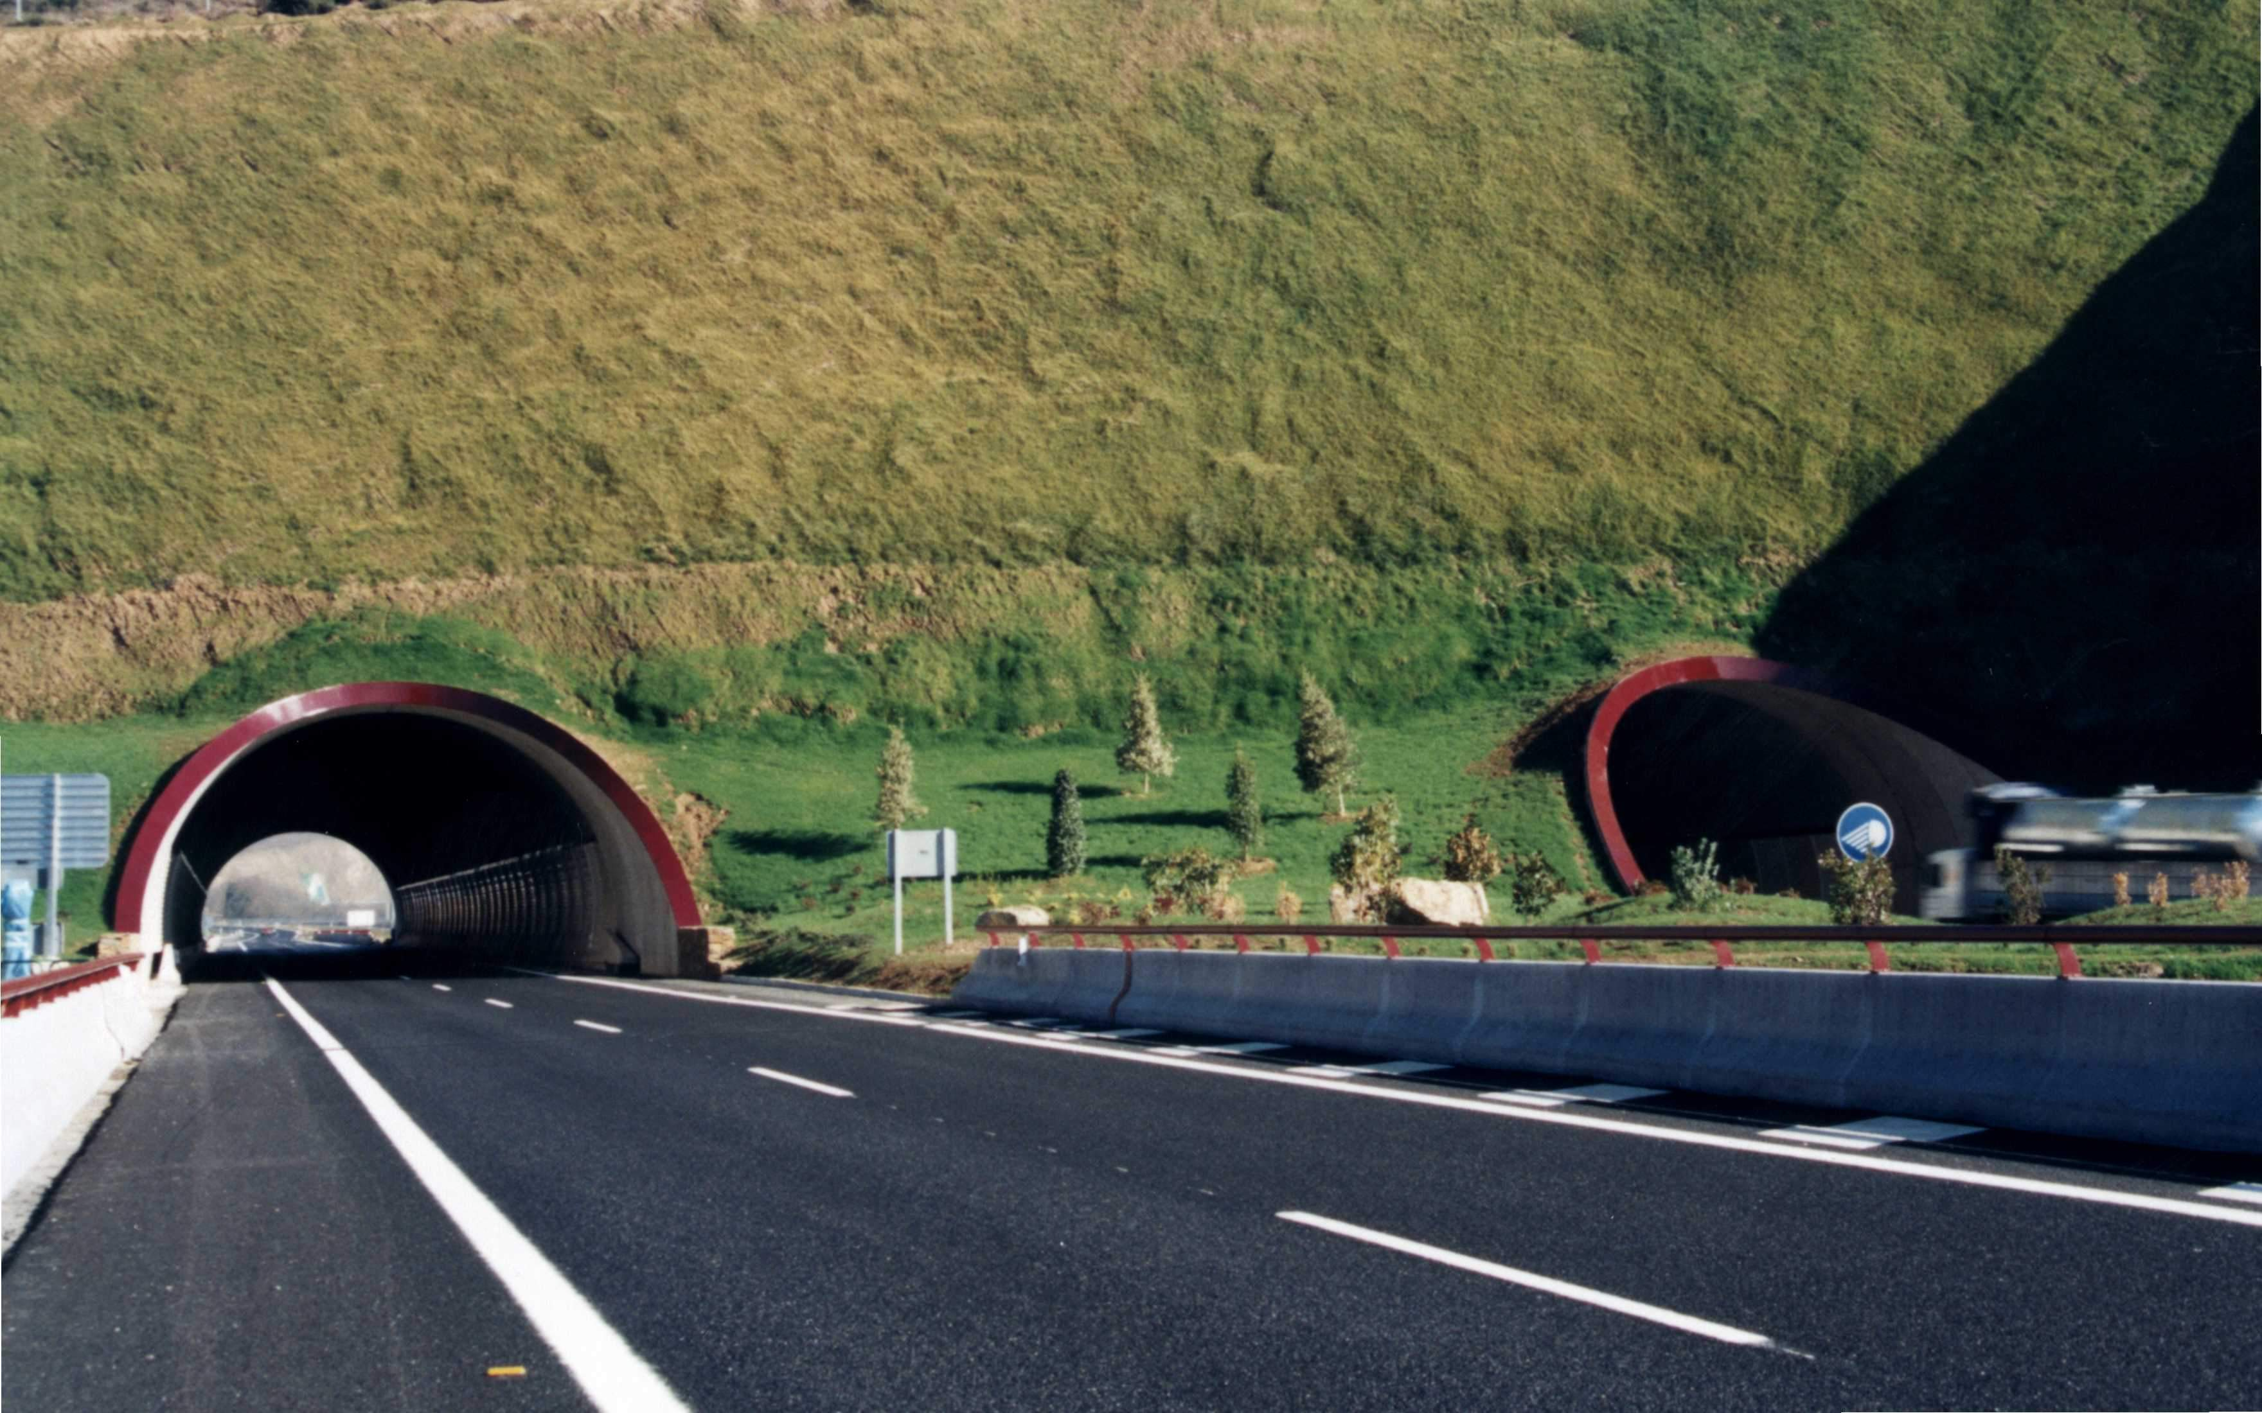
Figure 22: Twin road tunnel under high fill, Spain.
7 conclusion

Precast concrete buried arch structures provide an economic and reliable solution to providing access or waterways under high fills for transport structures, culverts, and conveyor tunnels. The fill load transferred to the arch will give rise to high compressive stresses in the arch and high foundation loads. High bending moments and shear stresses may also be generated, unless the arch profile is specifically chosen to suit the fill height. In addition longitudinal differential settlements and longitudinal loads may give rise to significant loads that need to be considered in the design. All these effects are now well understood, and with the aid of modern computer software and analysis methods, can be accommodated in the design, ensuring a trouble free construction and service life.

