Analysis and Design of Arch Structures for the Oman Southern Expressway
Doug Jenkins, Managing Director, Interactive Design Services

SYNOPSIS

This paper describes the analysis and design of a number of large precast buried arch structures for The Oman Southern Expressway, which is currently under construction. The arches are of 15 and 20 metres span, under embankments of up to 35 metres height. The fill height is substantially greater than for any previous buried arch structures of this size. A number of design challenges were encountered on this project:

- Analysis and design of the arch profile to minimise bending moments and shear forces in the structure under very high soil loads.
- Design and detailing of skewed structures for asymmetric loads.
- Design of raft foundations for very high imposed loads.
- Analysis and design of double arch structures.

The paper describes the analysis procedures employed on this project, and the design features required to support the high imposed loads. These included the use of a funicular arch profile and a raft cross section of varying depth. The paper compares the design actions in the actual structure with alternative designs, and makes recommendations for the design of arch structures under very high fills.

PROJECT DESCRIPTION

The Oman Southern Expressway is a 55 km long highway project currently under construction. The project includes 7 large precast arch underpass structures which were designed and supplied by Freyssinet International, using the TechSpan arch system. Two arch sections were used; 15 m span x 7.5 m rise and 20 m span x 10 m rise. The maximum fill height over the arches in the final design was 34 metres above base level, requiring careful design of the arch and raft foundation profiles to minimise bending moments in the finished structure, and to deal with the very high axial forces at the base of the arch. Other factors requiring careful analysis and design included:

- Fill over the arches was restrained by terraced reinforced soil retaining walls, resulting in stepped vertical loading on the arch, and resulting longitudinal loads on the arch and foundations.
- Several of the arches were constructed on a skew to the highway alignment, resulting in significantly asymmetrical loading to sections at the ends of the arches.
- At a late stage in the contract the maximum fill height was increased from 24 metres to 34 metres above base of arch level, and the arches under the highest fills were converted to double structures, resulting in significant interaction effects between the two structures.

A typical cross section of a 20 m span double arch is shown in Figure 1.

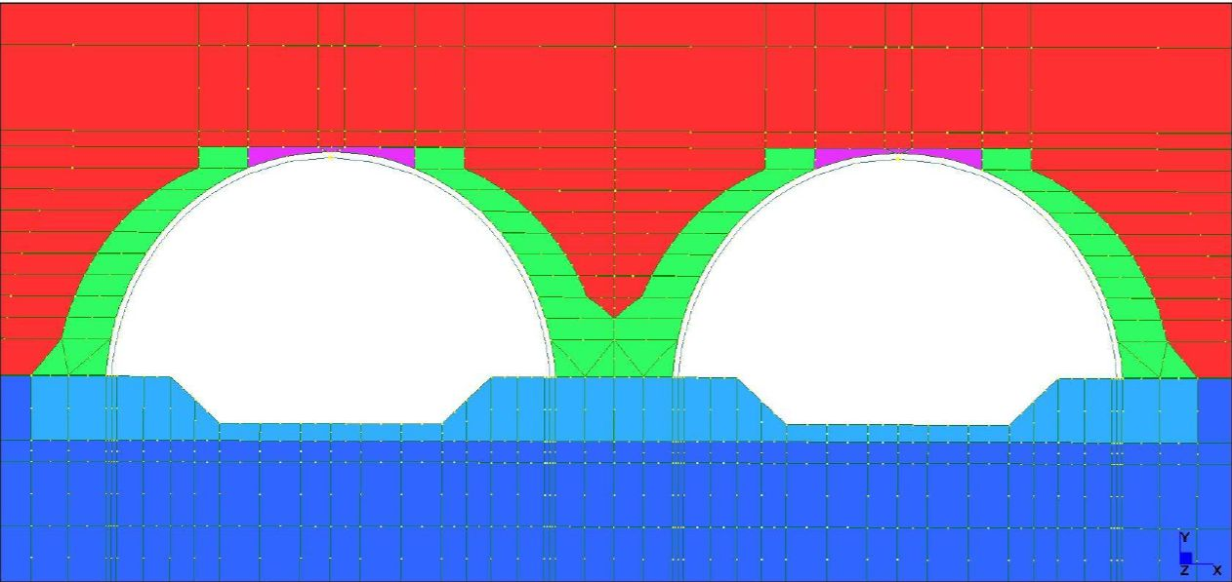
Figure 1: Detail of finite element model for double arch and raft

ANALYSIS PROCEDURES

The basic analysis for these structures followed the standard practice for buried arch structures, using Freyssinet in-house software:

- A 2D, plane strain, finite element analysis is carried out, modelling the arch, and the foundations and backfill within the zone of influence of the arch.
- An elasto-plastic soil model is used, with soil stiffness and Poisson’s ratio related to confining pressure.
- Soil loads are applied in stages reflecting the sequence of filling employed on site.
- For each backfill layer the fill is added to the model, and a compaction load is applied and then removed.
- A layer of “friction elements” is placed between the arch and the soil, allowing the soil to slip relative to the arch.
- The concrete is modelled as a linear elastic material.

A typical finite element model for an asymmetric loading condition is shown in Figures 2.

Additional analyses were carried out for this project to model the important project specific features. These were performed using the commercial finite element analysis package, Strand7, together with a purpose written Excel spreadsheet program using the Strand7 API to control the construction sequence. The basis of the analysis technique is to model all the soil layers required for the finished structure with a small gap between layers, and with all nodes initially restrained against translation, with a separate freedom case for each layer. The layers are then successively added to the active model by de-activating the layer freedom case, and connecting nodes across the gap with master/slave links. The analyses carried out in this way included:

- Asymmetric loading conditions at the ends of skew structures.
- Interaction effects between double arch structures.
- Longitudinal effects due to stepped loading under the terraced retaining walls at the ends of the structures.
- Analysis of the raft foundations, including raft foundations under double arches.
- Alternative fixity conditions at the base of the arch.

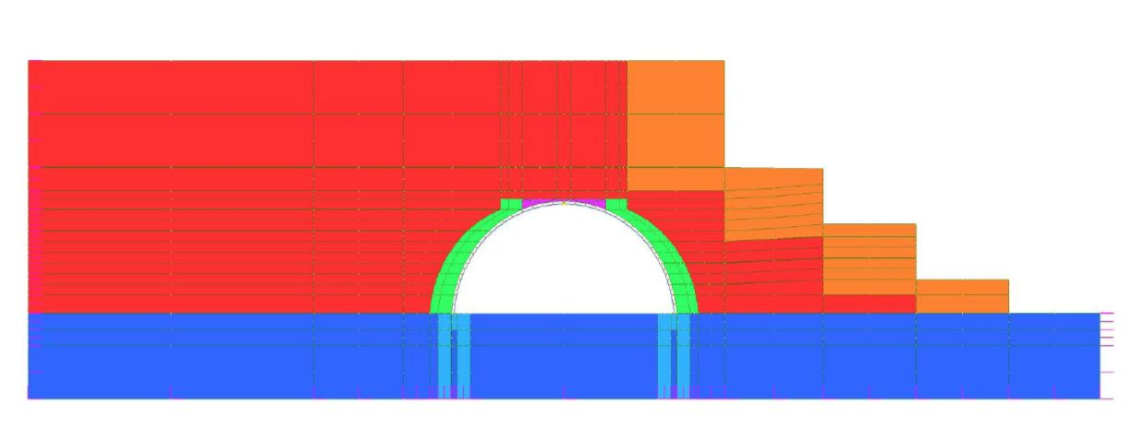
These analyses and their results are described in greater detail in following sections.

Figure 2: Section with maximum load eccentricity

ALTERNATIVE ARCH PROFILES

The TechSpan arch system uses project specific arch profiles, using a fourth order polynomial curve, designed to minimise bending moments and shear forces in the finished structure. This is particularly important with large arches subject to very high fills, where non-optimised arch profiles may generate very high bending moments that would make an arch solution impractical.

To illustrate the benefits of an optimised profile a semi-circular arch of 20 m span was analysed with a fill height of 34 metres, and compared with the profile actually adopted for this project. Arch actions under the full fill height are shown in Figures 3 to 5. It can be seen that maximum bending moments and shear forces are about 75% higher in the semi-circular profile compared with the optimised profile. The higher bending moment for the semi-circular profile would have necessitated a substantially thicker arch section,

Figure 3: Optimised Profile vs. Semi-Circle; Bending Moments

Figure 4:Optimised Profile vs. Semi-Circle; Shear Forces

Figure 5: Optimised Profile vs. Semi-Circle; Axial Forces
and it is likely that the additional stiffness of the thicker section would have resulted in still higher bending moments. Axial loads are almost equal for both profiles. The maximum axial force at the base of the arch is approximately 30% higher than the weight of fill directly over the arch plus arch self weight. Typical values for the ratio between arch axial force and overburden weight (sometimes known as the Marston Factor) vary between 1.0 for a structure on rock or very stiff soil foundations, up to 1.7 or more for a piled or raft structure on soft foundation soils (1).

CRITICAL LOADCASES

In a typical two piece precast arch project possible critical load cases are (positive bending = tension on the inside face):

- Handling; arch segment supported on its ends, positive bending
- Erection; arch self weight plus unbalanced loads plus construction wind loads, negative bending.
- Backfill; fill loads to the top of the arch, positive bending.
- Completed fill with shallow cover plus live loading, positive and/or negative bending.
- Completed fill with deep cover, positive or negative bending
- Completed fill with asymmetric, positive and/or negative bending

For this project the original critical loadcases were Case 2 (for reinforcement on the outside face) and case 3 (for reinforcement on the inside face). When the fill height was increased to 34 metres, this became the critical loadcase for reinforcement on the inside face, and additional reinforcement was required at the base of the arch to accommodate the combination of high axial load and bending moment.

Bending moment and load capacity diagrams for the critical loadcases are shown in Figures 6 to 8.

The finite element mesh for the most severe case of asymmetrical loading is shown in Figure 2, and the resulting bending moments in the finished structure in Figure 9. In spite of the asymmetric loading, this was not a critical loadcase for this structure.

RAFT DESIGN

The maximum unfactored load at the base of the arches was about 7,400 kN/m at the external supports, and a combined load of about 12,500 kN/m from both arches at the central supports. Provision of a system to support these loads on soil foundations provided a considerable challenge. Alternatives considered included piled foundations, soil improvement, and very large spread footings, but the solution ultimately chosen was the use of raft foundations with a variable depth, to reduce hogging moments in the centre of the raft.
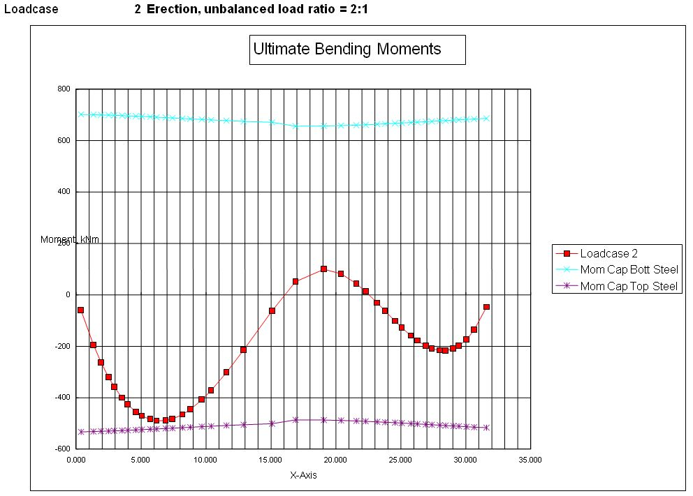

Figure 6: Maximum bending moments during erection
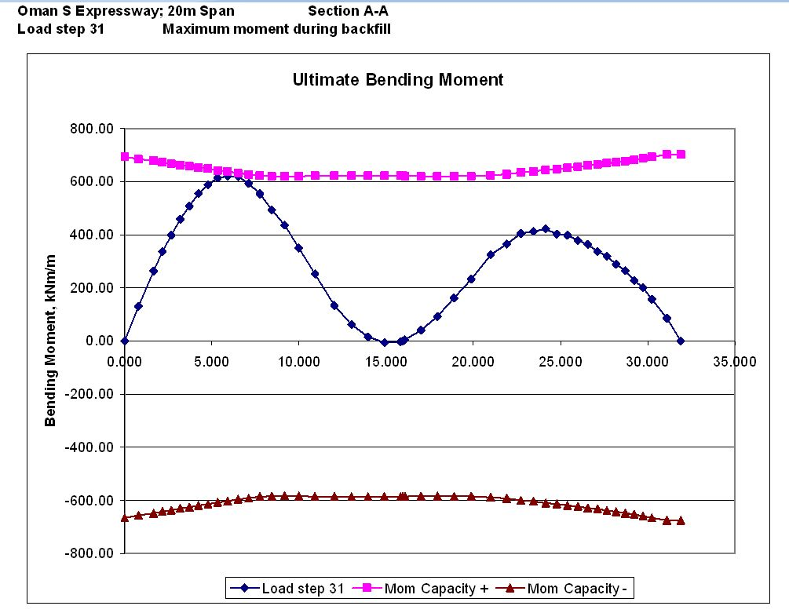

Figure 7: Maximum bending moments during backfill

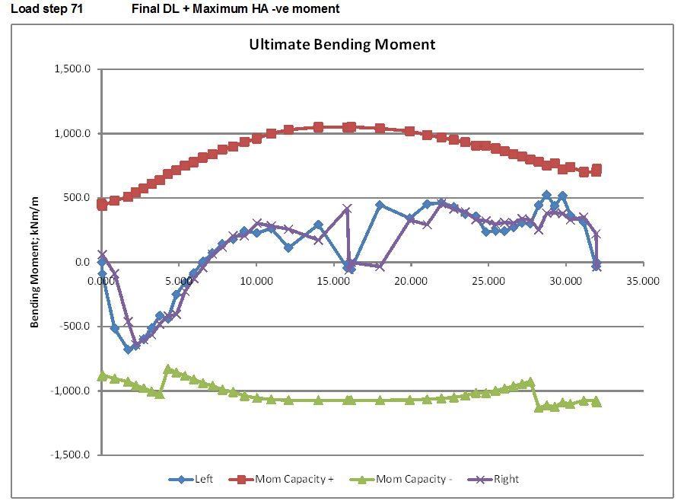

Figure 8: Maximum bending moments in the completed structure (34 m fill)
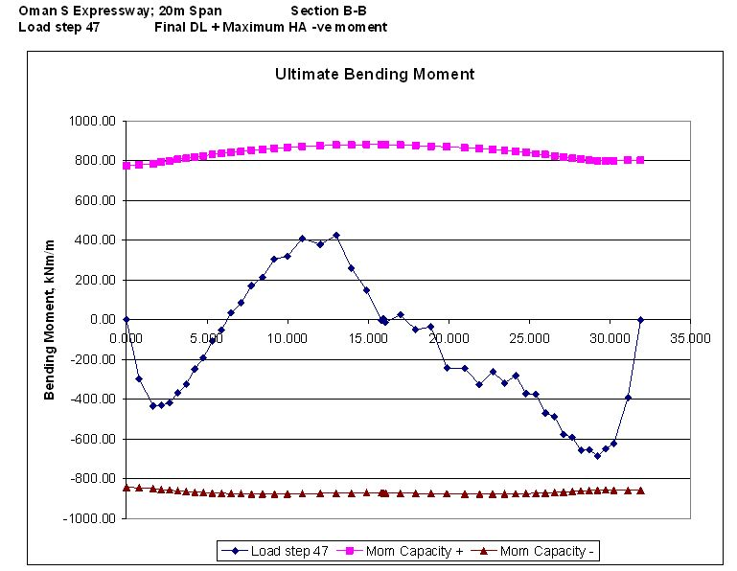

Figure 9: Ultimate bending moments with maximum load eccentricity

A typical raft detail is shown in Figure 1. Features of the raft include:

- The overall width of the twin raft was 55 metres.
- The depth of the raft was 3 metres under the arches, reducing to 0.8 metres in the mid span region.
- A movement joint was provided at the mid section between the two arches to avoid very high bending moments at this location.

The finite element model for the arch analysis included a sufficiently detailed model of the raft foundations to allow the same analysis to be used for both designs. For the double arches the fill cross sections were not symmetrical, so it was necessary to model both arches and a sufficient width of the embankment so that boundary conditions did not significantly affect the arch behaviour. The overall model width was about 130 metres for the maximum fill height analysis.

Typical raft stresses and deflections under maximum loading are shown in Figure 10; deflections are magnified 20 times. It can be seen that there is a significant net tension on the raft slab, which acts as a tie between the two deeper footing sections. Reduction of the depth of the raft between the footings greatly reduces the bending moment in the slab. For the maximum fill height unfactored bending moments in the slab as designed were about 1,250 kNm/m, compared with 19,000 kNm/m for a slab of 3 m depth.

LONGITUDINAL EFFECTS

Longitudinal loads on buried structures may arise from a variety of sources (1):

- Steep fill slopes or retaining structures above the structure.
- Segmental structures constructed on steep slopes.
- Longitudinal spreading of foundations under high fills.
- Longitudinal differential settlement effects on continuous structures.

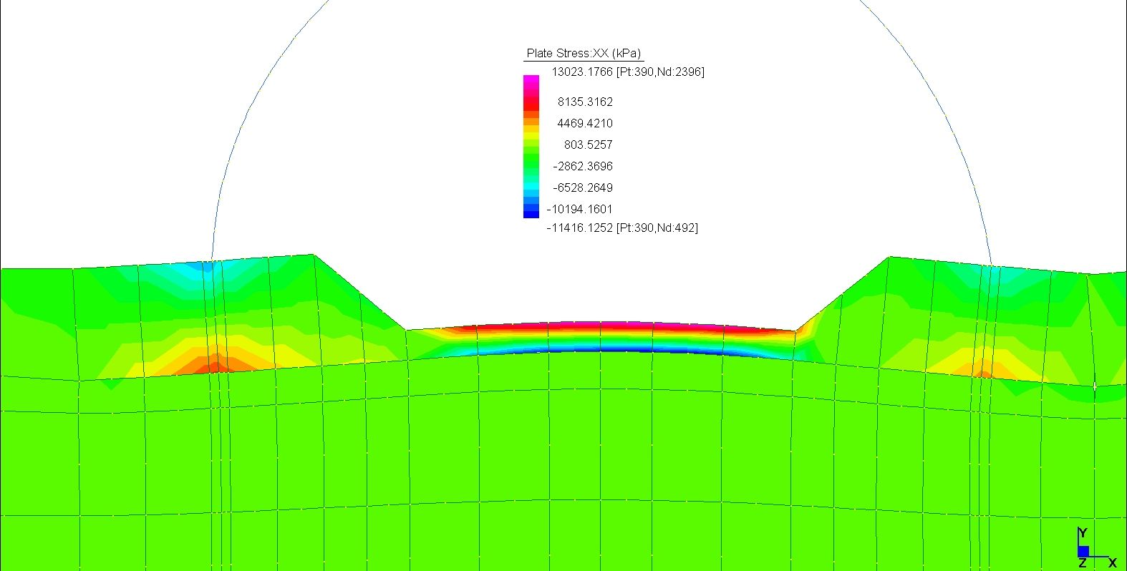

Figure 10: Stresses in raft foundation under maximum fill height

A number of buried arch structures in Japan and North America have suffered significant structural problems due to these loads, including:

- Spalling of arch crown joints.
- Inclined tension cracks at the base of arch elements.
- Differential twisting movement at the crown

For this project these effects were minimised by the provision of movement joints at all significant steps of vertical loading, nonetheless detailed longitudinal analyses were carried out to ensure that the size of the structures and the high fills did not give rise to unexpected effects. These included:

- Longitudinal 2D plane strain analyses through a section of embankment adjacent to the arch (Figure 11). Strains from these analyses were then applied to a 3D model of the arch to check overturning and twisting effects.
- 3D analyses of the arch with a surrounding block of fill, with vertical and horizontal loads simulating a retaining wall applied to the fill block (Figure 11).

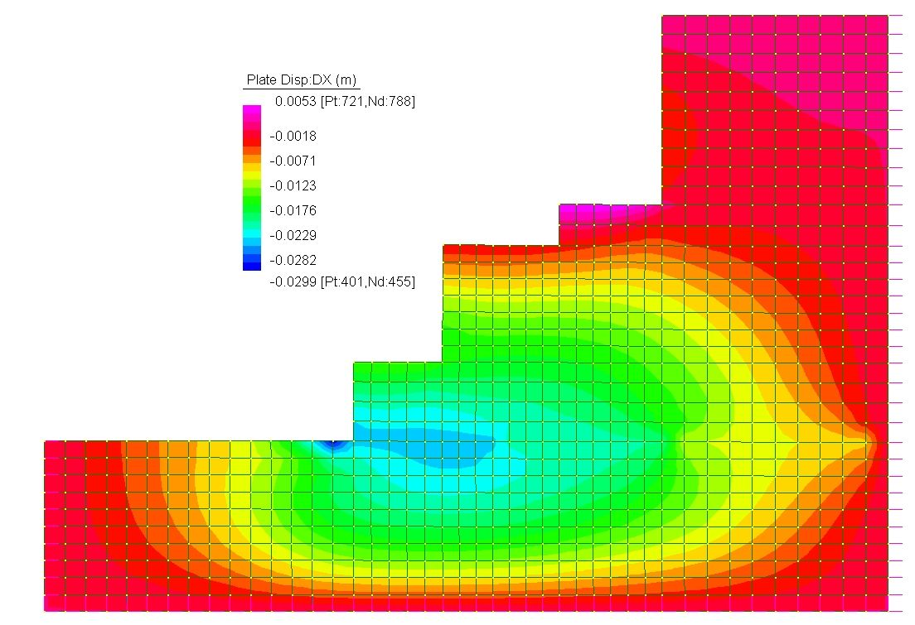
Figure 11: Longitudinal 2D Plane Strain Analysis

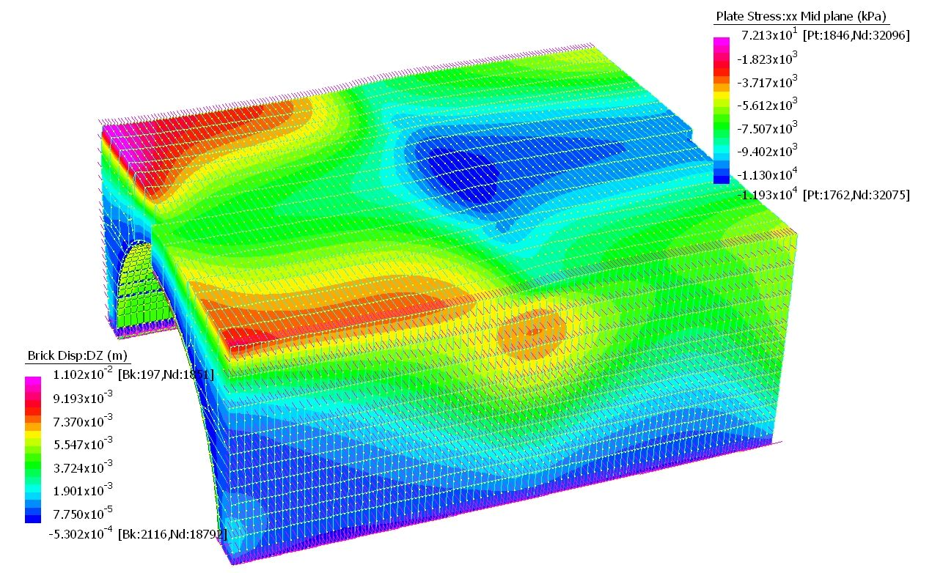
Figure 11: Longitudinal 3D analysis

RECOMMENDATIONS FOR DESIGN OF ARCH STRUCTURES UNDER HIGH FILLS

Precast concrete buried arch structures provide an economic and reliable solution to providing access or waterways under high fills for transport structures, culverts, and conveyor tunnels. The arches on the Oman Southern Expressway project represent a significant step in the maximum size of structure constructed under very high fills, and required careful attention to analysis, design and detailing to deal with the resulting high loads. Design for all arches under high fills should take account of the following considerations:

- Axial loads in the arch will be high, and may be significantly affected by the stiffness of the foundation soils and the type of foundation system. The arch analysis must therefore include the foundation soils, which should be given a realistic elastic modulus.
- The use of a non-optimised arch profile, such as simple semi-circular or elliptical curves, may give rise to very high bending moments and shear forces. Flat elliptical profiles are particularly unsuited to high fills.
- Significant savings in the design of raft foundations may be gained by adjusting the depth of the slab between the footing sections to minimise bending moments.
- Longitudinal effects may be significant under high fills, particularly for embankments with steep side slopes or high retaining walls, structures on steep slopes, and structures on soft or variable foundation soils. Design provisions include the use of movement transverse joints, and checking the structural effect of longitudinal loads, to ensure structural adequacy.

REFERENCES

- Jenkins, D. (2007). Soil Loads on Cut and Cover Tunnels Under High Fills. Concrete Institute of Australia Seminar “Design of Concrete for Soil Structure Interaction”. Sydney, March 2007:

