DESIGN OF PRECAST BURIED STRUCTURES FOR INTERNAL IMPACT LOADING

Doug Jenkins
Interactive Design Services Pty Ltd

18 Manor Road
Hornsby, NSW 2077

ABSTRACT

The use of precast cut and cover construction is becoming increasingly common for applications such as rail and road tunnels. It is vital that structures should be able to withstand high accidental impact forces without collapse, but simplified design methods may not give an accurate result for the ultimate capacity of the structure under impact loads. In this paper the interaction of a precast arch structure with the surrounding soil has been considered in analysing the behaviour of the structure under impact loads. The main features of the analysis were:

- A 2D plane strain finite element analysis was carried out, including the arch, surrounding fill and foundations.
- The fill was modelled as a mohr-coulomb elasto-plastic material.
- The moment-curvature behaviour of the concrete was modelled, including the effect of confinement reinforcement.
- The analysis considered both material and geometric non-linearity.
- Separate runs were carried out to assess the effect of fill stiffness and strength, and concrete section strength and ductility.

The paper compares the results of the following types of analysis:

- Simple analysis with equivalent static loads
- Non-linear analysis with equivalent static loads
- Non-linear “push-over” analysis

Recommendations are given for design and detailing procedures to comply with design code requirements and provide the maximum level of security against collapse under impact loading.

Keywords: Soil-structure interaction, concrete, arch, tunnel, impact, finite element analysis
INTRODUCTION

The current Austroads Bridge Design Code (Austroads 1992) requires bridge piers to be designed for an ultimate collision impact load of 2000 kN parallel to the rail centre line, and a transverse load of 1000 kN, applied simultaneously at a height of 2 metres above rail level. In the draft Australian Standard Bridge Design Code – Part 2, DR 00375, (Standards Australia, 2000) these loads are increased to 3000 kN and 1500 kN respectively.

The use of pre-cast cut and cover tunnels allows the use of comparatively thin wall sections, particularly for the range of spans typically adopted for arch structures for rail lines. Where simple methods are adopted for the analysis of impact loads it may prove difficult or impossible to provide the required resistance without increasing the thickness of the section. This paper describes the investigation of the interaction of a buried arch structure with the surrounding fill under transverse impact loading

ANALYSIS PROCEDURE

The analyses were carried out on the arch cross section shown in Figure 1. The arch has internal dimensions of 12.5 m span and 6.35 m height, and a thickness of 0.25 m. The precast units were taken to be 1.5 m wide, with the impact force distributed over the full width of one unit. These dimensions are typical for a twin track rail line. 2D plane strain analyses were carried out using Strand7 with the model shown in Figure 2. The main features of the analyses were:

- A 2D plane strain finite element analysis was carried out, including the arch, surrounding fill and foundations.
- The fill was modelled as a Mohr-Coulomb elasto-plastic material.
- The material between the pile caps and heads of the piles was taken to have negligible cohesion, to avoid the development of tensile forces between the pile caps.
- The precast arch section was modelled as beam elements. The moment-curvature behaviour of the concrete was modelled, including the effect of confinement reinforcement.
- The beam elements were connected to the soil elements through friction contact elements.
- The arch was assumed to have a 2 metre layer of select fill with controlled strength, stiffness and compaction parameters. The remaining fill was given varying stiffness over the range that would be encountered in practice.
- The analyses considered both material and geometric non-linearity.
- Separate runs were carried out to assess the effect of fill stiffness and strength, and concrete section strength and ductility.

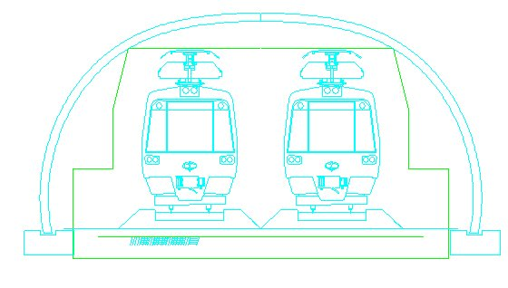
Fig. 1: Arch Cross Section

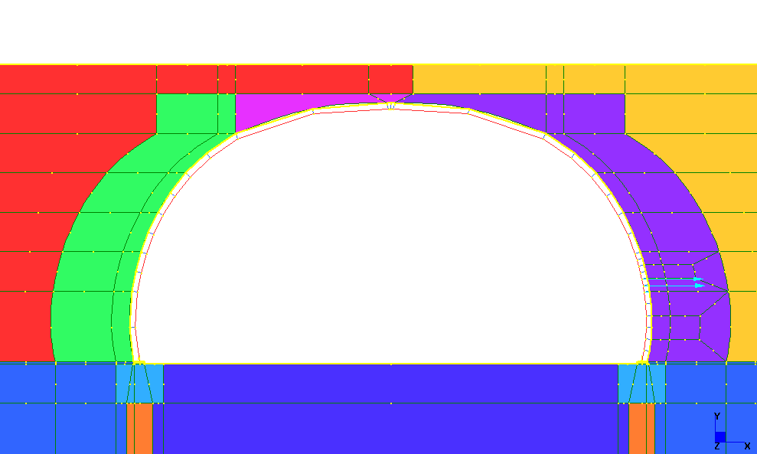
Fig. 2: Detail of finite element model

Initial runs used simplified models as follows:

- All materials linear elastic
- Non-linear soil model with linear elastic beams and no contact elements
- Moment-curvature behaviour of beams added
- Friction elements added
- Non-linear geometry added

The remainder of the analyses used Model 5, with the fill and concrete parameters shown in Table 1.

Table 1: Fill and Concrete Parameters
Run No. | Fill |  | Concrete
Run No. | Elastic Modulus, MPa | Poisson’s Ratio | Strength | Tensile Reinf. Density % | Ultimate Curvature, m⁻¹
6A | 10 | 0.3 | 40 | 0.76 | 0.30
6B | 30 | 0.3 | 40 | 0.76 | 0.30
6C | 60 | 0.3 | 40 | 0.76 | 0.30
6D | 30 | 0.3 | 40 | 1.72 | 0.087

The reinforcement was partially confined (ligatures at 150 spacing longitudinally and 500 transversely) for Runs 6A to 6C. For Run 6D full confinement in accordance with the Austroads Bridge Design Code was provided.

The moment-curvature of the section was determined using the Mander concrete model and the Park reinforcing model (Mander et al. 1988). The concrete in the cover regions was treated as unconfined; as a result provision of full confining reinforcement provided relatively little additional ductility, since the compression zone of the concrete was entirely within the cover region. The moment-curvature diagrams for the alternative reinforcement arrangements and concrete strengths are shown in Figure 3, and the ultimate curvature is given in Table 1.

Fig 3: Moment Curvature Diagrams

ANALYSIS RESULTS

The bending moment and shear force diagrams for Runs 1 and 2 under full impact load are shown in Figure 4. Both the bending moment and shear force are well above the maximum capacity of a 250 mm thick section with normal strength concrete. The use of non-linear soil properties with linear elastic beam properties in Run 2 slightly increased the maximum bending moments, and had little effect on maximum shear forces.

Fig. 4: Run 1-2 bending moments and shear forces

Fig. 5: Runs 3-5 bending moments

Fig. 6: Runs 3-5 shear forces

For Runs 2 to 5 the impact loading was applied in 20 equal steps. The maximum arch actions, deflections and curvature are shown in Figures 5 to 8.

Fig. 7: Runs 3-5 horizontal deflections
Fig. 8: Runs 2-5 curvature

The use of non-linear properties for the arch members in Runs 3 to 5 greatly reduced the maximum bending moments and shear forces, and increased horizontal deflections and maximum curvature. Insertion of friction elements to allow slip between the soil and the arch (Run 4), and inclusion of geometrical non-linear effects (Run 5), significantly increased the arch actions, deflections, and curvature. The results of Runs 2 to 5 are summarised in Table 2.

Table 2: Summary Run 2-5 Results
Run No | Bending Moment |  | Shear Force |  | X Deflection |  | Curvature
 | Max, kNm | % Run 5 | Max, kN | % Run 5 | Max, mm | % Run 5 | Max, m-1 | % Run 5
2 | 781 | 385% | 408 | 126% | 18.7 | 50% | 0.0033 | 3%
3 | 203 | 100% | 307 | 95% | 30.4 | 81% | 0.0537 | 42%
4 | 203 | 100% | 317 | 98% | 36.0 | 95% | 0.1065 | 84%
5 | 203 | 100% | 324 | 100% | 37.7 | 100% | 0.1266 | 100%

The maximum bending moment from the most detailed model (Run 5) has reached the ultimate bending capacity of the section, but the maximum curvature is less than 50% of the curvature capacity.

In the remaining runs the point of impact was displaced through 100 mm in 40 equal increments with varying soil and concrete stiffness parameters.

The development of applied load, bending moment, and curvature are shown in Figures 9-11.

Fig. 9: Runs 6A-6D, Bending Moment

Fig. 10: Runs 6A-6D curvature

Fig. 11: Runs 6A-6D Applied Force

The results of Runs 6A to 6D are summarised in Table 3.

Table 3: Summary Runs 6A to 6D results
Run No | Applied Force at 100 mm deflection |  | Deflection at 1000 kN applied load |  | Curvature at 1000 kN applied load |  | Ultimate Curvature | Ductility Factor
 | kN | % Run 6A | mm | % Run 6A | m-1 | % Run 6A | m-1
6A | 1309 | 100% | 60 | 100% | 0.2739 | 100% | 0.300 | 1.10
6B | 1546 | 118% | 35 | 58% | 0.1266 | 46% | 0.300 | 2.37
6C | 1603 | 123% | 28 | 46% | 0.0626 | 23% | 0.300 | 4.79
6D | 1726 | 132% | 30 | 50% | 0.0429 | 16% | 0.087 | 2.03

Runs 6A to 6C had a general fill stiffness of 10 MPa, 30 MPa, and 60 MPa respectively. For all three runs a 2 metre wide zone of select fill was assumed around the tunnel, and the stiffness of this was maintained at 50 MPa. The effect of increased fill stiffness is to reduce the deflection and curvature at the design impact load of 1000 kN/m. The ductility factor (ultimate curvature/curvature at design load) increases from 1.10 for soft fill to 4.79 for stiff fill. For run 6D intermediate fill stiffness was used (30 MPa) and the percentage of tensile reinforcement was increased from 0.76% to 1.72%. The section curvature at the design load was substantially reduced, but the reduction in the ultimate curvature of the section resulted in a reduced ductility factor (2.03, compared with 2.37 for Run 6B). It is therefore recommended good quality granular fill of medium to high stiffness be used for the general fill. Where this is not possible it may be necessary to improve the stiffness of the select fill zone (by cement stabilisation for example), to provide the required impact resistance. Increasing the bending capacity of the concrete is not recommended, since the reduction in section ductility is likely to be counter productive.

THREE DIMENSIONAL AND DYNAMIC EFFECTS

The study of three dimensional effects and dynamic effects is outside the scope of this paper. It is to be expected that the dissipation of the impact load in the third dimension (i.e. along the tunnel) will result in a substantial reserve resistance to impact loads. The fill stiffness values used in the analyses were based on typical static values, and it is likely that consideration of dynamic effects would allow higher values to be used, with a corresponding reduction in deflections and section curvature.

RECOMMENDATIONS

A linear elastic analysis of impact loads was found to result in unrealistically high bending moments and shear forces. Provision of heavily reinforced sections is likely to be counter-productive, due to the reduction of section ductility. The following procedure is therefore recommended for the impact load design of buried precast structures:

- Carry out a 2D finite element analysis of the impact load, assuming distribution of the load across one precast panel.
- The finite element model should include the fill and foundations within the zone of influence of the structure.
- The model should allow for slip between the structure and the soil, and should allow for both material and geometric non-linearity effects.
- The moment-curvature behaviour of the reinforced concrete should be modelled, based on an analysis of the actual reinforced concrete section.
- The required stiffness of the fill material should be included in the project specification.
Due to the severe consequences of the collapse of a buried structure, and the uncertainties in the analysis, it is recommended that an alternative load path be provided to maintain the stability of the structure, in the event of the failure of one precast panel.

CONCLUSIONS

- A linear elastic analysis of train impact loads on a precast concrete buried arch tunnel was found to overestimate the bending moments and shear forces in the structure by a considerable margin. The use of non-linear soil properties with linear elastic concrete properties increased the overestimation of the bending moments.
- When the moment-curvature behaviour of the arch section was included in the analysis, a typical arch section designed for dead and live loads was found to have adequate ductility for the railway impact loading specified in the draft Australian Standard Bridge Design Code.
- Slip at the soil/concrete interface, and geometric non-linearity effects were found to have a significant effect on the arch forces and deflections, and should be included in an analysis of impact loads.
- Increasing the amount of tensile reinforcement reduced the ductility of the section, and is therefore not recommended.
- The provision of confinement reinforcement had only limited effect on the section ductility, because the section was lightly reinforced and the compression zone was within the depth of the cover to the reinforcement.
- The fill stiffness had a significant effect on the curvature requirement. With low stiffness (10 MPa) fill, the ductility of the section used in this paper was only just adequate.
- Three dimensional distribution of the impact pressures through the fill, and the dynamic stiffness of the fill, have not been considered in this paper. These effect will provide an additional level of safety for structures subject to impact loading.
- It is recommended that an alternative load path be provided to maintain the stability of the structure, in the event of the failure of one precast panel.

REFERENCES

Austroads, 1992. “Austroads Bridge Design Code”

Standards Australia, 2000. “Draft Australian Bridge Design Code, DR 00374-00380

Mander, Priestly, Park, 1988. “Theoretical Stress-Strain Model for Confined Concrete”. J. Struct. Eng., ASCE, 114(8), p. 1804-1849.

