High Performance Concrete in Bridge Decks – Opportunities for Innovation

Doug Jenkins
Interactive Design Services Pty Ltd
Hornsby, NSW, Australia

The use of high performance concrete offers advantages in durability, ease of placement, and reduced creep and shrinkage, as well as increased compressive, shear and tensile strength. Offsetting these advantages are potentially reduced ductility and fire resistance, and increased unit cost. In this paper the international use of high performance concrete in bridge decks is reviewed, including reported benefits and problems, restrictions placed on strength grade, and special design provisions required for higher strength grades.

Case studies are presented, comparing the design benefits under Australian conditions, of using the current maximum strength grade permitted under the Bridge Code, and higher strength grades that may be introduced in the future. Recommendations are given for situations in which the use of high performance concrete is likely to be of overall benefit to the quality and economy of the structure.

1. INTRODUCTION

The use of high performance concrete in bridges is increasing rapidly world wide, in many areas largely driven by durability problems associated with reinforced concrete structures subject to de-icing salts and freeze-thaw conditions. In Australia typical exposure conditions are not so aggressive and use of high performance concrete in bridges is not common. In this paper the international use of high performance concrete in bridge decks is reviewed, including reported benefits and problems, restrictions placed on strength grade, and special design provisions required for higher strength grades.

The focus of the paper is on the direct economic benefits of the use of high strength concrete. The requirements of Australian codes and specifications relating to high strength concrete are discussed and case studies are presented illustrating the potential saving in materials from the use of higher strength grades.

2. WHAT IS HIGH PERFORMANCE CONCRETE?

The term “High Performance Concrete” (HPC) is in danger of becoming a marketing phrase with little meaning; it has been observed that in the USA all concrete suppliers claim that their product is high performance concrete because no-one wants to buy low performance concrete. Nonetheless the term can sensibly be applied to concrete that has specific superior properties, to satisfy specified performance requirements. The USA Federal Highways Administration (FHA) defines HPC as follows (1):

“A high performance concrete is a concrete in which certain characteristics are developed for a particular application and environments. Examples of characteristics that may be considered critical for an application are:
- Ease of placement
- Compaction without segregation
- Early-age strength
- Long term mechanical properties
- Permeability
- Durability
- Heat of hydration
- Toughness
- Volume stability
- Long life in severe environments”

The focus of this paper is on “High Strength Concrete” (HSC), that is concrete with high compressive strength, and associated properties. These include improved shear and tensile strength, high modulus of elasticity, high early age strength, and reduced creep deformation. Less desirable properties that may be associated with HSC include reduced ductility, reduced fire resistance, and greater susceptibility to early age cracking.

High strength in the Australian context is here defined as concrete with a characteristic 28 day cylinder strength greater than 50 MPa, and up to 100 MPa. Concretes of still higher strength are now available but are outside the scope of this paper due to their special design requirements and higher cost. A more general and detailed definition of High Performance Concrete in highway structures is given by Goodspeed (2).

3. INTERNATIONAL USE OF HIGH PERFORMANCE CONCRETE IN BRIDGES

3.1 General

HPC has been used for particular applications for well over twenty years, with the first International Conference on Utilization of High Strength Concrete being held in Stavanger, Norway, in 1987, and the most recent of these conferences, the seventh, held in Washington DC in June 2005. Early developments were centred in northern Europe and focussed on applications in longer span bridges as well as high rise buildings and offshore structures, with more general use becoming mandatory in some countries by the early 1990’s. These developments were summarised in “High-Performance Concretes, a State-of-Art Report (1989-1994) (3), which remains a valuable summary of HPC technology.

Over the past 10 years the use of HPC in short to medium span bridges has been actively promoted by government agencies in the USA and Canada, both for improved durability and efficiency in the use of materials. North American information resources on HPC available on the Internet include:

- “Bridge Views” (1) – http://www.cement.org/bridges/br_newsletter.asp
- “High-Performance Concretes, a State-of-Art Report (1989-1994)” (3)
- http://www.tfhrc.gov/structur/hpc/hpc2/contnt.htm
- “A State-of-the-Art Review of High Performance Concrete Structures Built in Canada: 1990-2000” (4) - http://www.cement.org/bridges/SOA_HPC.pdf
- “Building a New Generation of Bridges: A Strategic Perspective for the Nation” (5) -
http://www.cement.org/hp/

3.2 Scandinavia

In Norway the combination of harsh climatic conditions, a long coast line with many structures subject to chloride attack, and the development of concrete off-shore drilling platforms in the North Sea led to the early adoption of HPC. For instance in 1989 the Norwegian Roads Administration introduced a requirement for a water-binder ratio of less than 0.40, combined with the use of silica fume on all infrastructure projects (3). In the same year concrete with a characteristic cube strength of 105 MPa was introduced in the Norwegian concrete design code (6). Lightweight aggregates have been used in many Norwegian structures, particularly balance cantilever structures. Characteristic strengths are in the range 55 to 70 MPa, with densities in the range 1900 to 1950 kg/m³ (6).

The development of HPC in Denmark and Sweden was driven by the construction of the massive Great Belt and Oresund Link bridge projects, with construction starting in 1988 (3, 7). The concrete had to meet high performance requirements, however, the term “high performance concrete” (HPC) is not used in Denmark. Requirements can be high or low, but performance can only be “yes” or “no.” Therefore, per the Danish definition, there is no such thing as HPC. Nevertheless, in reality, concrete for the Link would be described as HPC according to USA terminology. (7)

3.3 France

The first use of the term high performance concrete (HPC) in France goes back to 1983 and the building of a bridge at Melun under the impetus of LCPC and SETRA (Research Agency and Bridge Department of the French Highways Administration, respectively)(8). The use of HPC in France has been mainly in the bridge, rather than the building sector. The reasons for this are firstly because high rise building is dominated by steel construction in France, and secondly because of the partnership between bridge owners and the concrete industry, leading to the formation of a joint government/industry group to advance the use of HPC, called BHP 2000 (8).

Concrete with characteristic strengths in the range 70 -80 MPa are now common in France, with significant progress being made in modifying codes and standards to address the use of HPC (9).

According to Virlogeux (10) “The development of high performance concrete is one of the major trends in recent years for concrete construction. High performance concrete and not only high strength concrete because the increased compactness is a major advantage for the long term durability of concrete structures.” Virlogeux sees the main benefit for standard and medium span bridges as being in increased durability, because “engineers cannot take a large advantage … from an increased strength” (10), however this opinion is not supported by recent studies on precast girder bridges carried out in the USA.

3.4 North America

The use of high strength concrete has a history of over 30 years in the USA (3), and over the last ten years the use of HPC in bridges has been actively encouraged by owner organisations in partnership with industry groups.

The AASHTO “Task force on Strategic Highway Research Program (SHRP) Implementation” developed and instituted the Lead State Program in 1996 (11). Seven “high pay off” SHRP technologies (including HPC) had been identified in 1987, and a strategy based on “Lead States” was implemented to encourage the utilisation of these technologies. The team members represented industry, FHWA, and eight states. Their mission was to promote the implementation of HPC technology for use in pavements and bridges and to share knowledge, benefits, and challenges with the states and their customers (12). A FHWA implementation survey published in March 2004 (13) reported that 44 out of the 50 American states had used HPC in specifications in the last 10 years and that the great majority had made changes to curing requirements and specified concrete strengths to allow the efficient use of HPC.

In 1999 the National Council Bridge Council (NCBC) and FHWA came to a cooperative agreement intended to develop and implement means to enhance the use and quality of concrete materials and bridge systems (14). The three key objectives were:

- Identify needs related to HPC practices and procedures in relation to bridge design and construction
- Develop new and improved HPC practices and procedures related to concrete construction
- Implement technology transfer, training, and outreach activities on new and improved HPC practices and procedures; and develop partnership opportunities and joint efforts between Federal, State, and local governments, academia, and the private sector.

“HPC Bridge Views”, a bi-monthly newsletter on implementation of HPC usage and associated technical issues, was the first product of this agreement. This publication is now up to issue 37, and all issues are available for free download on the Internet.

In Canada extreme climatic conditions and problems with durability led to the conclusion that the impenetrability of concrete cover was of paramount importance, and the development of HPC as the key element to achieve this aim (4). A network of centres of excellence on HPC, funded under the Federal Government “Centres of Excellence Programme”, commenced in 1990. In 1994 the network became known as Concrete Canada, and by 2000 network researchers had published over 400 papers (4). The majority of HPC bridges constructed in Canada to date have had concrete strengths in the range 50-60 MPa, however the Canadian Standards Association (CSA) concrete code (A23.3-94) covers compressive strengths up to 80 MPa, and the Canadian Highway Bridge Design Code (CSA S6, 2000) has a compressive stress limit of 85 MPa, unless otherwise approved (4).

The Cement Association of Canada’s review of HPC Structures in Canada (4) provides further detailed information on Canadian structures and code requirements.
4. USE OF HIGH PERFORMANCE CONCRETE IN AUSTRALIA

The use of high strength concrete in Australia has been led by the building industry where competition in the high-rise building sector has led to the use of concrete with strengths of 100 MPa and higher for highly loaded columns.

Until the introduction of the Australian Standard Bridge Code (AS 5100) (15) in 2004 the maximum strength of concrete in bridges was limited to 50 MPa, and use of HPC in bridges has been mainly limited to structures in particularly aggressive environments. An example of the use of HPC for durability reasons is the Sorrell Causeway Bridge in Tasmania, where high performance concrete with a low w/c ratio and high slag and silica flume content was used to minimise shrinkage and reduce the ability of surface chlorides to diffuse (16).

Whilst many documents relevant to the specification, production and use of HPC, particularly with reference to concrete durability, have been produced by organisations such as The Concrete Institute of Australia (17-22), and Austroads (23-26), it is fair to say that there has not been a coordinated strategy to implement HPC use in bridges, such as has occurred in North America and France. This is not to say that there has been no activity in HPC research and development. The use of higher strength grades has been actively researched by Australian universities (for instance 27-31), and revisions to the Australian Standard Concrete Code (AS 3600) (32) covering the use of concrete with compressive strengths up to 100 MPa are in hand. However there has been little published research examining the economic benefits of the use of higher concrete strengths in Australian Bridges, and there is no national coordination or implementation programme for High Performance Concrete.

5. ECONOMICS OF HIGH STRENGTH CONCRETE

A number of studies of the economics of using concrete with higher compressive strengths in precast pre-tensioned bridge girders and in-situ bridge decks have been published in the USA (33-36). These studies were broadly in agreement; the main conclusions being:

- Beam sections that have a large bottom flange are efficient for HPC applications (33).
- The most significant property is compressive strength at transfer. Allowable tension at service has a minor impact (33, 35).
- For AASHTO beam sections, maximum spans were increased between 20 and 45 percent when the concrete strength was increased from 41 to 96 MPa and when strand diameter was increased from 12.7 mm to 15.2 mm (34)
- Use of 15.2 mm strand was most effective when girder strengths exceeded 55 MPa (34).
- With AASHTO Type 1 to Type IV girders, using 15.2 mm strand, concrete strengths greater than 83 to 90 MPa did not significantly increase maximum span lengths (34). See Figure 1 and Table 1.
- The strength of the composite deck had little influence on the maximum span of high strength girders (34).
- The availability of HPC allows designs with longer spans, fewer girder lines, and shallower girder sections, depending on the parameters of the project (35).
- Maximum useful concrete strengths with I and bulb-T girders are in the range 62 to 69 MPa with 12.7 mm strand and up to about 83 MPa with 15.2 mm strand. With U beams with a wide bottom flange and three rows of strands strengths up to 97 MPa are beneficial (36).

These recommendations are reviewed in the Australian Context in Sections 6 and 7 below.

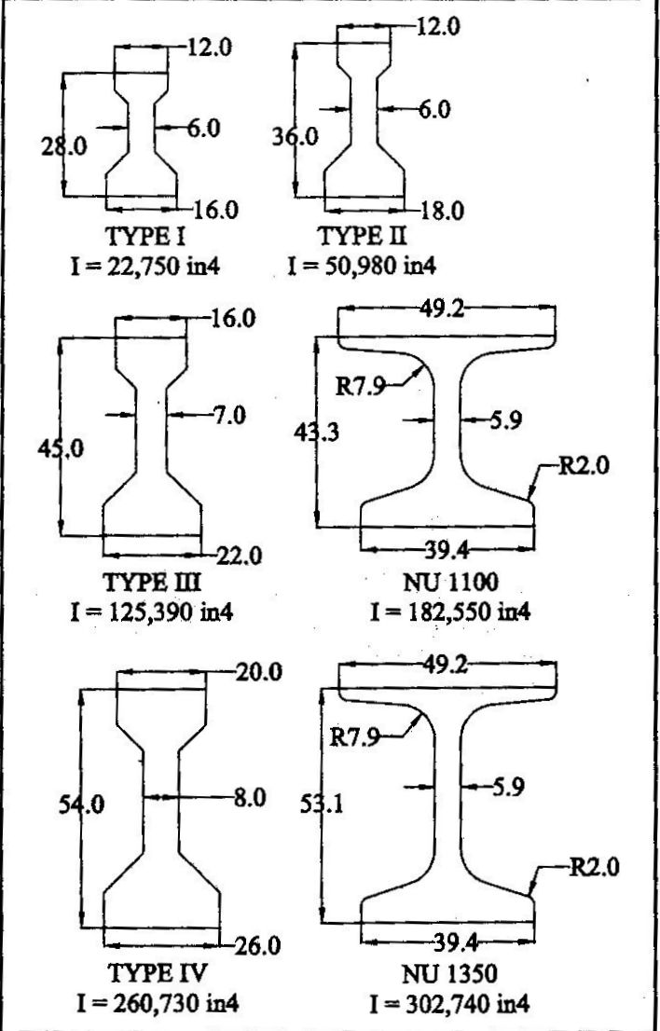 | 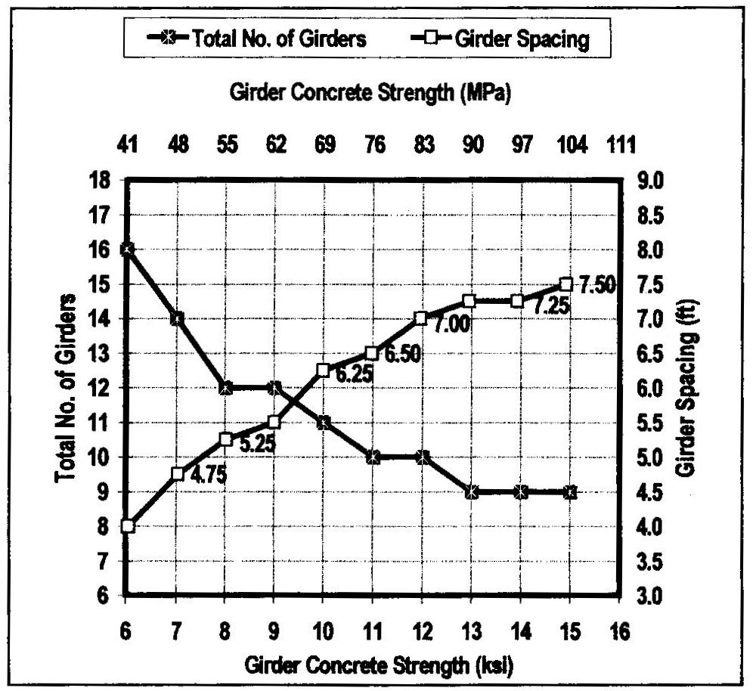
Figure 1 - AASHTO Standard Girders (34) | Figure 2 – Effect of concrete strength on girder spacing and numbers (34)

6. AS 5100 PROVISIONS FOR HIGH STRENGTH CONCRETE

With the introduction of AS 5100 the Australian Bridge Design Code was extended to cover the low range of high strength concrete (compressive strength up to 65 MPa) for the first time, and maintained compatibility with the Concrete Structures Code, AS 3600-2001. In addition to the characteristic compressive strength requirements the following clauses are relevant to the design of high strength concrete bridges:

“1.5.1 Provided that the requirements of Section 2 are met, this Standard shall not be interpreted so as to prevent the use of materials or methods of design, or construction not specifically referred to herein.”

This clause has been retained from the previous bridge code, and allows the use of higher strength concrete than that covered by the Code, subject to approval of the client and adequate justification of design parameters.
“2.5.2 The maximum concrete compressive stress under the fatigue design loading specified in AS 5100.2 shall be limited to the smaller of 0.45 f ′c and 18 MPa.”

This clause appears to place an unrealistically low compressive stress limit on high strength concrete in prestressed structures subject to fatigue loading. In practice the compressive stress in service in composite structures is only likely to exceed 18 MPa under fatigue loading in structures with concrete at the upper end of the HSC range, nonetheless it is desirable that this requirement should be reviewed to cover higher strength grades.

“6.11 The deflection limits of a road bridge under traffic for serviceability limit state shall be appropriate to the structure and its intended use, the nature of the loading and the elements supported by it.
SLS Live load + DLA: 1/600 span or 1/300 cantilever
In addition, road traffic bridges shall be designed so that—
(a) deflections do not infringe on clearance diagrams;
(b) hog deflection does not exceed 1/300 of the span; and
(c) no sag deflection occurs under permanent loads.”

The elastic modulus of concrete is approximately proportional to the square root of the compressive strength. Where high strength concrete is used to increase girder spacing or reduce girder depth it is possible that deflections under live load will increase and may become critical.

“6.1.1 (b)(ii) f'ct may be: … (ii) determined statistically from flexural strength tests carried out in accordance with AS 1012.11.”

Increased tensile strength provides some increased bending capacity with no increase in prestressing force, which may be further enhanced if testing shows higher tensile strength than that given by the code.

“6.1.7. (a) The basic shrinkage strain of concrete may be: …
(ii) determined from measurements on similar local concrete; or
(iii) determined by tests in accordance with As 1012.13

6.1.8.1 The basic creep factor of concrete … shall be: …
(b) determined from measurements on similar local concrete; or
(c) determined by tests in accordance with As 1012.16

6.1.8.2 The design creep factor (φcc) of concrete shall be determined from the basic creep factor (φcc.b) by any accepted mathematical model for creep behaviour, calibrated such that φcc.b is also predicted by the chosen model.

6.4.3.3 The loss of prestress due to creep of the concrete shall be calculated from an analysis of the creep strains in the concrete. …”

High strength concrete has significantly less long term creep deflection than lower strength grades, and may have lower long term shrinkage, but the default shrinkage strain given in AS 5100 does not vary with concrete strength, and the creep factor is constant for strengths over 50 MPa. It may therefore be worthwhile to use measured creep and shrinkage parameters, and to carry out a detailed creep and shrinkage analysis, to reduce design prestress losses. It should be recognised that if concrete compressive stresses have been designed close to the allowable limits overall long term strain may be increased when high strength concrete is used, especially if maximum allowable compressive stresses are applied at transfer.

7. CASE STUDIES

The following case studies illustrate the potential for either reducing girder spacing or reducing girder depth by using concrete with characteristic compressive strength in the range 65 to 100 MPa with standard Super-T open top pre-tensioned girders. Maximum span lengths have been calculated for standard Super-T girders, and the optimum design has been investigated for a typical three lane overbridge with 28.5 m simply supported span with M1600 loading, placed to produce the most severe loading effects on an exterior girder.

The maximum span length achievable with varying levels of prestress and concrete grade was found for the girders listed in Table 2. For each level of prestress the minimum concrete grade was used that satisfied the stress requirements at transfer. For the larger girders (Types 4 and 5), 65 MPa concrete was adequate for the maximum level of prestress that can be achieved by placing 15.2 mm diameter strand on a 50 mm grid within the bottom flange. To investigate the effect of higher levels of prestress a standard Type 4 girder was modified as follows:

- Increase bottom flange width by 200 mm to allow 20 strands in each layer (Type 4A)
- Increase bottom flange depth by 50 mm to allow one additional layer (Type 4B)
- Increase bottom flange depth by 100 mm to allow two additional layers (Type 4C)

The following parameters were assumed:

- Compressive strength at transfer = 0.7f’c.
- Steam curing applied (hence strand relaxation applied at time of transfer)
- Strand stressed to 80% specified tensile strength.
- Creep, shrinkage, and temperature stresses in accordance with AS 5100.
- In-situ concrete 40 MPa, 160 mm thick in all cases.
- Assumed girder spacing = 2.7 m.

Table 2: Super T Section Propeties

The results of the analysis are shown in Figures 3 and 4. The main features are:

Increasing the concrete grade to 65 MPa increased the maximum span of each girder type by from 13% to 14%. Grade 80 concrete increased the span capacity of Type 1 and 2 girders by 21% to 23% over Grade 50 concrete, but for Type 3, 4 and 5 girders the available strand locations were already filled with Grade 65 concrete, and an increase to 80 MPa gave little further benefit.

Modifying the Type 4 section to allow more prestress to be applied increased the maximum span, compared with a standard Type 4 section with grade 50 concrete, by 38%, 23%, and 30% for type 4A, 4B, and 4C sections respectively.
All available strand locations were filled with Grade 80 concrete in the modified girders, and little additional capacity would be gained by using Grade 100 concrete or higher.

Figure 3: Maximum span, standard Super-T girders
Figure 4: Maximum span, modified Super-T girders

For the typical bridge studied, 5 Type 4 girders with 34 strands would have been required with Grade 50 concrete. Use of grade 65 concrete would allow the use of Type 3 girders with 44 strands, and Grade 80 concrete would allow the use of modified Type 2 girders with 56 strands.

Alternatively, maintaining Type 4 girders and increasing the girder spacing, Grade 65 concrete would provide adequate capacity with 4 girders with 42 strands, and Grade 80 concrete would allow the use of 3 modified type 4 girders with 64 strands.

The study shows that significant savings in concrete quantities and/or construction depth are achievable by using Grade 65 concrete with standard girders, or Grade 80 concrete with modified girders. To achieve significant savings from Grade 100 or higher strength concrete would need more substantial changes to the beam cross section and method of construction.

8. CONCLUSIONS

The history of the introduction of HPC in bridges in Europe and North America shows a clear correlation between the extent to which government and bridge owner organisations have actively promoted the use of HPC and the penetration into the bridge market. In all cases the superior durability of dense high strength concrete has been the original motivation for the active support of HPC, but in many cases, particularly in North America, the use of higher strength grades has been found to give a significant direct economic benefit in reduced materials and transportation cost and/or reduced bridge construction depth. Studies in the USA have found the optimum strength grade using existing standard bridge beams to be in the range 60 – 90 MPa, and these strengths have been found to be achievable in practice provided due attention is paid to the special requirements of HPC. Optimisation of beams to allow higher prestress forces may result in concrete of still higher strengths proving economical.

In Australia code restrictions on design strength have resulted in HPC only being specified where a particularly aggressive environment demands special attention be paid to durability. Case studies using typical Australian precast bridge girders and composite bridge construction show the potential for similar savings to those found in the North American studies. The following actions are recommended to encourage the greater use of high strength, high performance concrete in Australia:

- 65 MPa to be considered the standard concrete grade for use in precast pre-tensioned bridge girders and post tensioned bridge decks.
- The use of 80-100 MPa concrete to be considered where significant benefit can be shown.
- AS 5100 to be revised to allow strength grades up to 100 MPa as soon as possible.
- Optimisation of standard Super-T bridge girders for higher strength grades to be investigated.
- Investigation of higher strength grades for bridge deck slabs, using membrane action to achieve greater spans and/or reduced slab depth.
- Integrated action by government and industry bodies to ensure education of designers, pre-casters, and contractors in the requirements for producing high quality high strength concrete bridges.

10. REFERENCES

1. Federal Highway Administration, Bridge Views Issue No. 1, Jan/Feb 1999, “What is HPC for Bridges?”.
2. Charles Goodspeed, Suneel Vanikar, and Ray Cook, "HPC Defined for Highway Structures", Concrete International, February 1996, The American Concrete Institute.
3. Paul Zia, Shuaib Ahmad, and Michael Leming, “High-Performance Concretes, a State-of-Art Report (1989-1994)”, FHWA 1995.
4. John A. Bickley and Denis Mitchell, “A State-of-the-Art Review of High Performance Concrete Structures Built in Canada: 1990-2000”, The Cement Association of Canada, May 2001.
5. “Building a New Generation of Bridges: A Strategic Perspective for the Nation”, Portland Cement Association, Washington DC, 2005.
6. Federal Highway Administration, Bridge Views Issue No. 11, Sep/Oct 2000, “Lightweight Aggregate Concrete in Norwegian Bridges”.
7. Federal Highway Administration, Bridge Views Issue No. 11, Sep/Oct 2000, “The Oresund Link Concrete Strategy”.
8. Federal Highway Administration, Bridge Views Issue No. 11, Sep/Oct 2000, “The 20 Years of HPC Bridges in France”.
9. “HPC gains high profile in global market”, Concrete Products, August 2002,
10. Michel Virlogeux, “New trends in prestressed concrete bridges”, Structural Concrete, Nov 2002, Thomas Telford and FIB.
11. M.W. Beacham, “High-Performance Concrete Lead State Team Activities: Overview”, High Performance Concrete: Research to Practice, ACI SP-189, 1999.
12. Federal Highway Administration, Bridge Views Issue No. 2, Mar/Apr 1999, “AASHTO Lead State Implementation”.
13. Federal Highway Administration, Bridge Views Issue No. 32, Mar/Apr 2004, “HPC Implementation Status” and “HPC Guide Specification for Bridges”.
14. Federal Highway Administration, Bridge Views Issue No. 1, Jan/Feb 1999, “HPC Implementation”.
15. Standards Australia, “AS 5100-2004, Australian Standard Bridge Code”, SAI Global, Sydney.
16. Bruce Gibbens, Peter Selby Smith, Graeme Joynson, “Sorell Causeway Channel Bridge, Tasmania”, Austroads Bridge Conference May 2004.
17. CIA Current Practice Note 25 - 2003, “Fly Ash and its Use in Concrete”, Concrete Institute of Australia, Sydney.
18. CIA Current Practice Note 26 - 2003, “Ground Granulated Iron Blast Furnace Slag and Its Use in Concrete”, Concrete Institute of Australia, Sydney.
19. CIA Current Practice Note 27- 1992, “Condensed Silica Fume and Its Use in Concrete”, Concrete Institute of Australia, Sydney.
20. CIA Recommended Practice Z-07-2001, “Durable Concrete Structures”, Concrete Institute of Australia, Sydney.
21. CIA Recommended Practice Z-09-1999, “Curing of Concrete”, Concrete Institute of Australia, Sydney.
22. CIA Recommended Practice Z-13-2001, “Performance Criteria for Concrete in Marine Environments”, Concrete Institute of Australia, Sydney.
23. Austroads AP-R245/04, “Concrete Durability - Development of Models to Predict and Extend the Service Life of Concrete Bridges”, Austroads, Sydney.
24. Austroads AP-T28/03 , “Guidelines for Ensuring Specified Quality Performance in Bridge Construction”, Austroads, Sydney.
25. Austroads AP-T07/00 , “Service Life Prediction of Reinforced Concrete Structures”, Austroads, Sydney.
26. Austroads AP-127/97, “Concrete Structures Durability, Inspection and Maintenance Procedures - Position Paper”, Austroads, Sydney.
27. T.D. Ngo, P.A. Mendis, D. Teo, G. Kusuma, CIA Concrete Conference 2003, “Behaviour of high-strength concrete columns subjected to blast loading”.
28. F. Papworth; G. Hastie, “Production and Application of Silica Fume and Geosilica”, CIA Concrete Conference 2003
29. M.F.M. Zain; M. Safiuddin; A. Ilham; H. Mahmud , “Effect of Quarry Dust on the Physical Properties of High Performance Concrete”, CIA Concrete Conference 2001.
30. S.J. Foster, “Design of HSC Colums: Strength and Ductility”, CIA Concrete Conference 2001.
31. A. Wheeler; R.Q. Bridge, “Design of Concrete Columns to AS 3600-2001”, CIA Concrete Conference 2003.
32. Standards Australia, “AS 3600-2001, Concrete Structures”, Standards Australia, Sydney.
33. M.K. Tadros, X. Huo, Z. Ma, M. Baishya, “Structural Design of High Performance Concrete Bridges”, High Performance Concrete: Research to Practice, ACI SP-189, 1999.
34. Kahn, L. F. and Saber, A., “Analysis and Structural Benefits of High Performance Concrete for Pretensioned Bridge Girders,” PCI Journal, Vol. 45, No. 4, July/August 2000, PCI.
35. J.A. Weigel, S.J. Seguirant, R. Brice, B. Khaleghi, “High Performance Precast, Pretensioned Concrete Girder Bridges in Washington State,” PCI Journal, March-April 2003, PCI.
36. Henry G. Russell, “Maximum Effective Concrete Strengths in Pre-tensioned beams Beams”, Bridge Views Issue No. 33, May/Jun 2004, FHWA.

