Arch Structures; Spanning Past Present And Future

D.A. Jenkins
Engineering Manager

Reinforced Earth Pty Ltd

Synopsis: Arch structures are one of the oldest forms of engineering construction, and continue to find new applications in many different fields. This paper reviews significant developments in the history of the arch, from the time of the Romans through to the Twentieth Century. Historical theories of arch design are examined, and compared with our current state of knowledge, achieved with the aid of Finite Element Analysis and measurements of actual structures. Finally possible future developments are considered, examining new developments and proposals ranging from low cost culvert structures up to large span bridges which take advantage of the advantages of precast concrete arch construction in economy, aesthetics, and durability.

Keywords: arch, bridges, arch design, history, concrete, funicular curves, precast concrete arches, precast concrete

Introduction

There are three structures in Sydney that are exceptional by world standards. All three are arches (Figures 1 and 2). This paper presents a review of the history leading up to the construction of these three structures and some ideas about the future of arch bridges.

Figure 1 Sydney Opera House Roof and Sydney Harbour Bridge | Figure 2 Gladesville Bridge

Roman Bridges

The art of building arch bridges seems to have arrived, fully formed, some two thousand years ago, perhaps inspired by natural arch structures. The Roman bridge builders were not only the first to use arch structures of any significant size, their structures were also almost unsurpassed in size for nearly two thousand years, and many examples survive in use to the present day (Figures 3 and 4). Their construction methods included the use of concrete and coffer dams, allowing the construction of
foundations in locations that would be regarded as difficult even today .

Medieval Bridges

Following the fall of the Roman Empire there was no significant bridge construction in Europe until the Twelfth Century, but in China the An Ji Bridge (figure 5) built at Zhao Xian in the seventh century AD, showed design features not to be repeated for 1000 years (1). It's shallow segmental arch

Figure 3 Pont du Gard | Figure 4 Puente de Alcantara

Figure 5 An Ji Bridge | Figure 6 Pont d'Avignon

and open spandrels were strikingly different to the full semi-circular arches and filled spandrels typical of Roman arches.

In Europe the end of the 12th Century saw renewed activity in building by the church. As well as building cathedrals and monasteries the building and maintaining of bridges at dangerous crossings was seen as an act of pious charity (1). According to legend the Pont d'Avignon (Figure 6) was built by a shepherd after a vision in 1178. With parabolic spans exceeding 30 m span it was the first medieval European Bridge to compare with Roman engineering achievements.

The Industrial Revolution

The Industrial Revolution saw rapid advances in bridge design and construction throughout Europe. The rate of advance is exemplified by two Scottish bridges (Figures 7 and 8) by Wade (2). Whilst masonry arch bridges continued to be used right through the 19th Century it was in the use of cast iron, and later steel that the greatest advances were being made.

The Ironbridge (Figure 9), completed in 1779, was the first bridge built of cast iron. With a semi-circular span of 30 metres the iron members are entirely in compression, and do not take advantage of

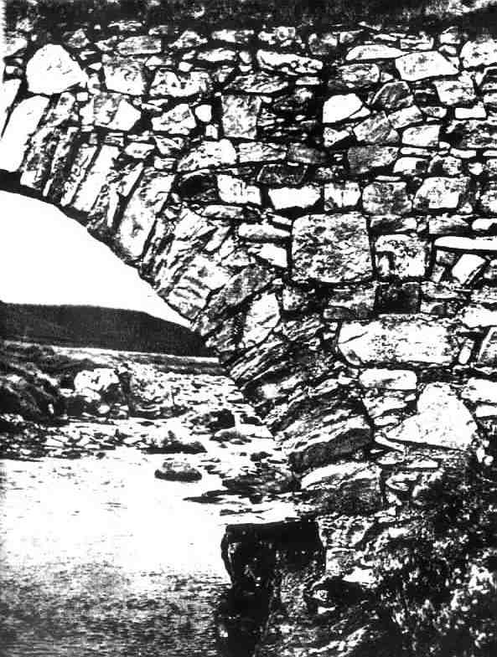 | 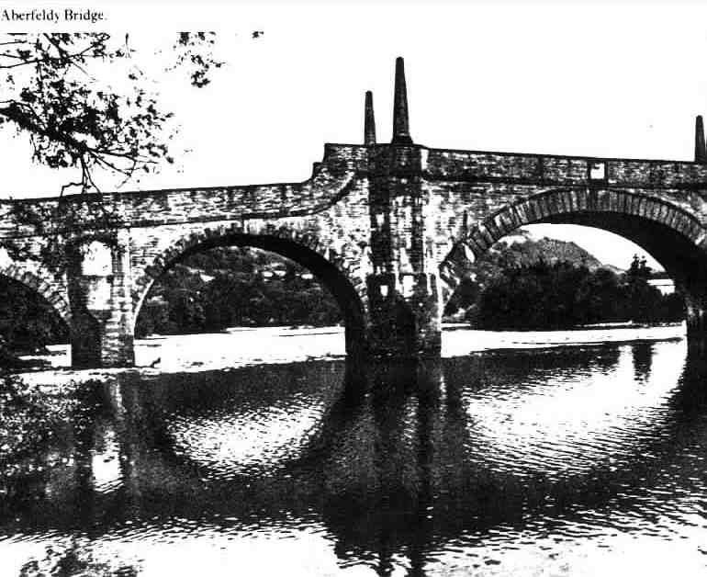
Figure 7 Bridge near Dalwhinnie | Figure 8 Bridge at Aberfeldy
the possibilities of the new material. This cannot be said of two iron arch designs proposed by Thomas Telford (Figures 10 and 11). His 1800 design for a replacement for London Bridge had a single span of 183 metres. His proposals for erecting an iron arch bridge over the Menai Straights were prophetic of modern construction techniques. Brunel's Royal Albert Bridge at Saltash (Figure 12) was equally innovative, combining flat arches of wrought iron with suspension cables which also restrained the ends of the arches. This bridge also saw an early use of prefabrication, with the complete spans being jacked into place in 0.9 metre stages. The St Louis Bridge (Figure 13) (completed in 1874) was the first large steel structure ever built, and was also the largest bridge ever built at the time, with three spans of 158 metres. This structure was the first and only bridge designed by James Eads.

The Industrial Revolution also saw many fine timber bridges, a famous surviving example being the Mathematical Bridge at Cambridge (Figure 14), built in 1749. A much larger structure of similar design was the Walton Bridge (Figure 15), opened in 1750. It's main span of 130 ft was the longest in Britain at the time, and it became the subject of two paintings by Canneletto. The bridge's owner, Samuel Dicker, claimed that it could last for 200 years, but in reality it only lasted 35 years before decay of its timbers required demolition.

Figure 9 The Ironbridge | Figure 10 Arch for the Menai Straights
Figure 11 Single Span Arch Design for London Bridge by Telford

Figure 12 Brunel's Saltash Bridge | Figure 13 St Louis Bridge

Figure 14 The Mathematical Bridge | Figure 15 Old Walton Bridge

THEORIES OF ARCH DESIGN

One of the earliest attempts to derive a theory of arch design was by the English scientist Robert Hooke. At the end of a printed lecture on "Helioscopes and some other instruments" in 1676 he inserted the following problem "to fill up the vacancy" (2):

"The true mathematical and mechanical form of all manner of arches for building, with the true butment necessary to each of them. A problem which no architectonick writer hath ever yet attemted, much less performed"

The solution to this problem was given in the form of a Latin anagram, which when solved and translated read: "As hangs the flexible line, so but inverted will stand the rigid arch." The equation for the curve of a hanging flexible line or catenary was derived twenty years later by David Gregory, who expanded Hooke's assertion (2):

"When an arch of any other figure is supported, it is because in its thickness some catenaria is included"

The shape of a stretched string under a given set of loads is known as a funicular curve, from the Latin for string. The same term (or sometimes anti-funicular) is applied to arch profiles designed to resist the applied loads in pure compression. In 1695 funicular curve theory was developed by Philippe de la Hire in Paris to account for the weight of fill and spandrel walls over the arch. This approach was further developed in England by William Emerson who first derived the shape of spandrel required to maintain a semi-circular arch in equilibrium, and later derived arch shapes that would be maintained in equilibrium by spandrels with a horizontal top surface (Figure 16).

Emerson's ideas were partially validated by the collapse and subsequent successful completion of a very slender single span arch bridge at Pontypridd in Wales (Figure 18). William Edwards, a self taught mason, had contracted to build a bridge over the Taff for £500 in 1746. His first attempt was demolished by a flood after two years. Being liable for maintenance for seven years he decided to construct a single span bridge, which failed when the centring collapsed shortly before completion. His next design was extremely light and thin, and collapsed by breaking upwards at the crown. The final structure, which still stands today, reduced the weight of fill near the abutments by the inclusion of cylindrical voids through the spandrels. The completed structure at 140 ft span was the longest arch in Britain, and remained so for forty years (3).

In 1759 the City of London invited designs for a new bridge across the Thames at Blackfriars. The resulting public controversy over the relative merits of the competing designs throws interesting light on the state of knowledge at the time. The bridge committee received over fifty submissions, which were reduced to eleven. Eight of these were "elliptical in shape", including one by Robert Mylne which appears to have been favoured by the Committee until one or more members objected that the elliptical arches were "deficient in strength and stability". It was decided that the matter would be decided by a panel of eight "gentlemen of the most approved knowledge in building geometry and mechanics."(2) While the panel was deliberating the designs became a matter of public debate with contributions from Dr Samuel Johnson and an apparently well-informed writer who signed himself "Publicus" and is believed to have been Robert Mylne himself.

Johnson's argument, written in layman's terms , was persuasive, but lacked any understanding of the behaviour of arch structures (2):

"If the elliptical arch be equally strong with the semicircular, that is, if an arch, by approaching to a straight line, looses none of its stability, it will follow that all arcuation is useless… But if a straight line will bear no weight, which is evident to the first view, it is plain like wise that an ellipsis will bear very little, and that as an arch is more curved its strength is increased."

Mylne's explanation of his design, whilst showing a clearer understanding of "normal" arch behaviour, introduces a feature which is surely fanciful in it's supposed effect on the forces at the abutments (2):

"…so that, if I understand it right, all from the haunches of the arch downward becomes a pier or abutment, to support a small part of the arch in the middle as a segment of a circle. This middle part, if built like other arches would make a lateral pressure against these abutments, but to take that away he has placed cubical stones, which he calls joggles, in the joints of the arch; so that every stone tends to fall perpendicularly by its being carried along with the one above it, and nor shoved aside as in other arches, which is the cause of the lateral pressure."

 | Figure 17 Mylne's Design for Blackfriars Bridge
Figure 16 Early Arch Design Theories | Figure 18 Pontypridd Bridge
Figure 19 Funicular And Simple Curves Compared

Mylne regarded a design by John Smeaton as being his most serious competitor; he described the architecture of Smeaton's design as "the meanest and poorest of all the designs". Smeaton defended his design, not from any textbook's rules, but from his own measurements of standing bridges and to some extent from theoretical studies. He wrote:

"As he does not know that the quantity of the lateral pressure of the arches, under different circumstances, have ever been truly and clearly determined, he diligently applied himself to this work…he has given such a size and form to his middle piers, as will resist several hundred tons more lateral pressure, than the middle arch will exert thereon".

Unfortunately no record of Smeaton's investigation survives. Mylne's original design was ultimately accepted by the panel of "experts" (who included a clergyman, the Astronomer Royal, a teacher of medicine, a lawyer, and two professors). The only mathematical appraisal of the designs appears to have been carried out by a Thomas Simpson, a professor of mathematics, whose early career included being tutored by a pedlar and achieving some fame as a village fortune-teller. Simpson's calculations showed that Mylne's arch
was thicker than necessary, and that the size of pier needed to resist the horizontal thrust was virtually identical for both elliptical and semi-circular designs. Simpson was working on extending these studies into a treatise on arches, but after his early death one year later his papers were given by his widow to a military officer, who refused to let them be seen again.

The state of knowledge of arch design was clearly still in a confused state by the middle of the 18th Century. Refinements of methods of arch design and analysis continued to be developed throughout the 19th and 20th Century. Leliavesky (4) quotes methods by Melan, Kogler, and Cochrane. More recently Ridley-Ellis (5) has published computer programs for design of optimum arch profiles based on the equation:

$\text{y }=\text{ r' }+\text{ d' }\left\{\text{1 - cosh }\left(\left(\text{1 - 2}\frac{x}{s}\right){\text{ cosh}}^{\text{-1}}\left(\frac{\text{d' }+\text{ r'}}{\text{d'}}\right)\right)\right\}$
These various methods of design and analysis give results broadly in agreement, with varying degrees of precision, but give rise to arch profiles quite different to the semi-circular and circular arc profiles used in historical structures. This apparent paradox has a simple explanation, all of the methods discussed above neglect the horizontal pressure from the arch fill! When horizontal loads are considered it can be shown that the funicular curve shape is intermediate between a circular arc and a parabola for very high fills, and lies outside the circular curve for shallow fills (Figure 19). Comparisons of field measurements and finite element analysis of arches designed using funicular curve theory are given by Jenkins (6,7).

Figure 20 Details of a Monier Bridge | Figure 21 Grafton Road Bridge

The Twentieth Century

The invention of reinforced concrete brought many new possibilities for arch bridges, and Australia and New Zealand have been at the forefront in these developments. At the turn of the century a number of insitu concrete arches using the Monier system were constructed in Melbourne and Bendigo (Figure 20). The construction of these arches has recently been documented by Monash University (8), giving a fascinating picture of the construction practices of the time. Skew spans of up
to 28 metres with a rise of only 3 metres, were achieved; although the largest span collapsed during testing when the City Surveyor insisted on doubling the test load!

In New Zealand the Grafton Road Bridge (Figure 21) was completed in 1910. With a Span of 98 metres and height of 45 metres it was the largest reinforced concrete arch in the World at the time of its completion, and it remains an imposing structure, especially when viewed on foot. The use of reinforced concrete allowed the use of an open spandrel structure and support on discrete bearings.

In Europe the foremost early exponent of concrete arch bridges was undoubtedly the Swiss engineer, Robert Maillart. His bridges are as much aesthetic as technical achievements. His best known structure is the Salginatobel Bridge completed in 1930 (Figure 22). With a span of 90 metres it is not an exceptionally large structure, but the grandeur of its site is unmatched (9). A contemporary of Maillart, the French engineer Eugene Freyssinet is best known for his work on pre-stressing, but earlier in his career he completed many significant structures, including the Plougastel Bridge (Figure 23), consisting of three 180 metre spans. This bridge is significant not only for its size, but also for the ingenuity of its floating formwork system, and the investigations of concrete creep which Freyssinet carried out during the construction of this bridge.

Figure 22 Salginatobel Bridge | Figure 23 Floating Formwork for Plougastel Bridge

Figure 24 Gladesville Bridge | Figure 25 Sydney Harbour Bridge

Concrete arch bridge construction reached its peak in Australia with the construction of the Gladesville Bridge in 1964 (Figure 24). Offered as an alternative to a steel cantilever bridge its design was developed in conjunction with Freyssinet, the final design being by Maunsell and Partners. The bridge is of precast prestressed construction, and at 305 metres span was the longest concrete arch in the World, only exceeded in 1980 by the completion of the Krk bridge in Croatia.

Sydney Harbour is of course home to another concrete arch structure of still greater renown. The roof of the Sydney Opera house presented the engineers Ove Arup (10) with many challenges in designing a structure that could be manufactured and built efficiently, whilst satisfying the requirements of the architect (Figure 26).

Construction of large steel arches became popular after the First World War, and reached a peak with two steel arch bridges of almost identical span. The Sydney Harbour Bridge at 503 metres was to have been the longest span arch in the world, but in 1931 The Bayonne bridge was completed with just 0.6 m greater span. The Sydney bridge is however over twice the weight of it's rival, being designed for both road and rail traffic, and had a far more complex construction method, being cantilevered from each bank (Figure 25).

The crown for the longest arch structure passed to the New River Gorge Bridge in West Virginia (Figure 27) in 1978, with a span of 518 metres. An indication of the scale of this bridge is given by the span between its vertical truss supports, at 42.5 metres nearly 1.5 times the total span of the original Ironbridge at Coalbrookdale.

The Future Of Arch Bridges

In the Twentieth Century developments in high tensile strength materials threatened to displace the arch from a significant place in bridge construction. However in spite of these developments arch
bridges retain their traditional benefits of aesthetic appeal, durability and economy. Over the past 10-15 years there has been a worldwide increase in the use of buried pre-cast concrete arch systems (11). Australia has been a leader in this trend with projects such as at the Homebush Bay Rail Link in Sydney (Figure 28) and Melbourne's Olympic Park Tunnel.

For larger bridges, structures such as the bridge by Calatrava (Figure 29) in Barcelona and a series of arch bridges on Japan's Hanshin Expressway (Figure 30) illustrate the potential for design of structures that are both visually striking and economical in the use of materials.
Figure 26 Changes to the Sydney Opera House Roof Design

Conclusion

The durability of arch structures has been proved by a history of over 2000 years. Finite element analysis combined with instrumentation of actual structures has now given us for the first time a clear understanding of the behaviour of buried arches, and the ability to confidently optimise arch designs
for economy, and to minimise bending moments in the completed structure. Precast concrete has several features that make it a particularly appropriate material for arch construction:

- High compressive strength at comparatively low cost.
- The ability to form any desired shape cheaply and accurately.
- Erection without elaborate formwork.
- Low maintenance and excellent durability, particularly under compression.

It is to be expected that the use of buried arch structures will continue to grow, with extension of the range of spans both downwards for use in culverts and pedestrian subways, and upwards to 30 metres and more. For larger spans also, modern analysis and erection techniques will improve the economy of arch bridges. After more than 2000 years it seems that the history of the development of arch bridges, far from reaching an end, has only just begun.

Figure 27 New River Gorge Bridge | Figure 28 Homebush Bay Rail Link

Figure 29 Bridge by Calatrava | Figure 30 Shin Hamadera Bridge

References

- Brown D.J., "Bridges", Mitchell Beazley, London, 1998
- Ruddock T., "Arch Bridges and Their Builders", Cambridge University Press, 1979
- Coventry, W., "A History of Pont-y-ty-Pridd"
- Leliavesky, S., "Arches and Short Span Bridges", Chapman & Hall, London 1982
- Ridley-Ellis D. http://www.ccc.nottingham.ac.uk/~evxdjr/intro.html
- Jenkins,D.A. “Analysis of Buried Arch Structures; Performance versus Prediction” CIA Biannual Conference, Adelaide, 1997
- Jenkins,D.A. “Non-Linear Analysis of Buried Arch Structures;” ASEC, Auckland, 1998
- Holgate A., "Monier Arch Bridges of Bendigo", Monash University, 1997
- Bill M., "Robert Maillart", Artemis Verlag fur Architektur, Zurich, 1969
- Arup, O., "Sydney Opera House", Sydney Opera House Trust, 1980
- Melbourne, C., "Arch Bridges", Proceedings of the First International Conference on Arch Bridges", Thomas Telford, London, 1995

More correctly Mylne's arch was composed of compound circular curves, see Figure 17
That is the ends of the larger central radius

